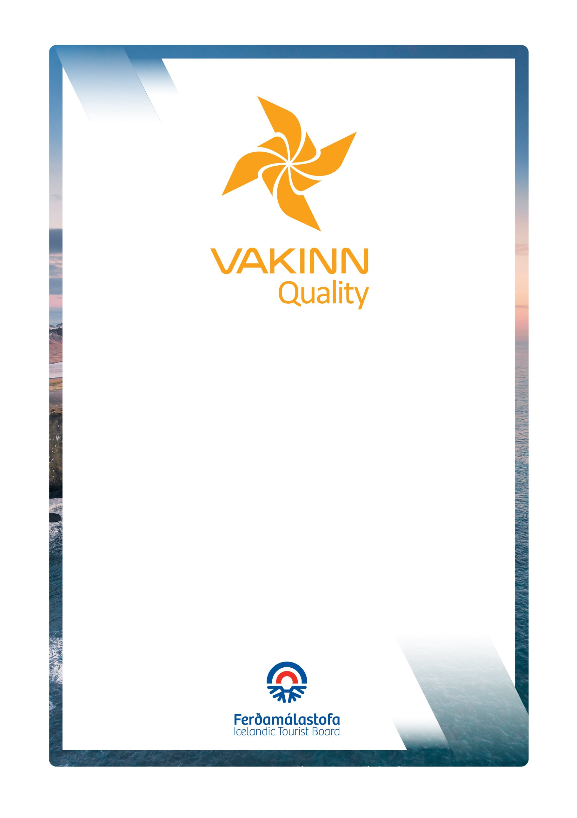
Accommodation

4th edition 2023
Quality – and Environmental Certification
On the Way to Sustainable Tourism

vakinn.is

General Quality Criteria
Gönguferðir í dreifbýli, óbyggðum
og í fjalllendi við sumaraðstæður

Sértæk gæðaviðmið nr. 200
5. útgáfa 2022
VAKINN – Gæða- og umhverfisvottun ferðaþjónustunnar
Á leið til sjálfbærrar ferðaþjónustu

vakinn.is

Following criteria, if applicable, must be fulfilled. Documents and/or photos are required as a confirmation on how the criteria is fulfilled.
1. Information
1.1 |  | The company operates a website and/or page on social media with reliable photos and detailed information that is updated regularly.
1.2 |  | Photos and information on the company´s website and in other promotional material show responsible behaviour towards nature. The company encourages customers to travel responsibly
1.3 |  | The Vakinn logo with a certification number and a text about the certification is prominent on the company’s website and in other promotional materials (applicable for Vakinn-certified companies).
1.4 |  | Terms and conditions concerning confirmation fee, cancellations and customer’s absence (no show) and regulations of refund are clearly stated on the company’s website or in the booking process.
1.5* |  | Information are in rooms or in the reception area, regarding opening hours, inhouse rules, breakfast hours, check out and other services available.
1.6 |  | Customers are encouraged to submit reviews, suggestions and/or complaints.
1.7 |  | If souvenirs are offered for sale those are produced in the region or in Iceland.
2. Management and Human Resources
2.1* |  | Specific quality criteria applicable to the operation has been filled in. F.ex. for guesthouse, hostel etc. If the company offers recreation as well such as horse riding trips, hiking, kayaking etc. appropriate specific quality criteria have to be filled in.
2.2* |  | An employee- and/or quality manual is in place and is formally presented to the staff. The manual covers i.a.:  - The company‘s strategy and values.  - Vakinn‘s quality – and environmental certification (applies after the company has received certification).  - Vakinn´s Code of Ethics.  - Safety plans.  - Environmental- or sustainability policy.  - The company's emphasis and rules regarding the natural environment and responsible travel behaviour.  - Occupational safety, i.e. Health and safety plan for the workplace.  - Service policy, communication and procedures.  - Other policies of the company e.g. personnel policy, policy against bullying and harassment.  - How to answer inquiries.  - How to receive and handle complaints.  - Cleaning plans and infection prevention.  - Rules on uniforms/attire, cleanliness and personal hygiene.
2.3 |  | Employees know the content of the quality manual and follow the work procedures described there.
2.4* |  | The company complies with applicable laws. All relevant licences and permits are valid and visible for guests as appropriate. If the company has a licence from the Icelandic Tourist Board, the licence logo is visible on the company´s website and on other promotional material.
2.5* |  | The operation is run in accordance with the current Act on accounting procedures and pertaining regulations. The customer gets a receipt for purchased services, indicating, among other things, VAT and the seller´s name, identity number and VAT number.
2.6* |  | Overnight statistics are submitted monthly to Statistics Iceland.
2.7* |  | Written employment contracts are drawn up for all employees.
2.8* |  | Job descriptions, defining employees’ roles and responsibilities, are available for all positions.
2.9* |  | All employees carry nametags (or are otherwise identifiable) with their own name and/or the company name (badges and/or uniform).
2.10* |  | Written procedures for training and orientation of new employees are in place.
2.11 |  | Employees have been trained and/or have completed courses according to quality criteria applicable to the operation (see chapter on education and training in each criteria, cf. 2.1.)
2.12* |  | The company maintains a list of employees detailing education and formal training. The list is updated at least annually.
2.13* |  | There are written procedures for receiving, handling and preservation of complaints and feedback that staff is familiar with.
2.14* |  | A manager (and/or an employee with managers support) is responsible for the company´s quality- and safety system according to Vakinn´s criteria. The knowledge of other key employees is guaranteed.
3. Safety and Hygiene
3.1* | Safety plan for the accommodation is in place and is reviewed at least once a year. Responsible party is defined.  The safety plan is reviewed once a year and more often if needed, especially in the wake of accidents or other mishaps. The safety plan includes the following:  - Risk assessment – a precise analysis of risks in the environment where a service is performed or goods are sold, that may potentially lead to accidents.  - Written work procedures – description of work procedures that should be followed to minimise risk of accidents.  - Contingency plan – how to respond in the case of accidents and/or mishaps.  - Incident report – registration of all irregularities, mishaps and/or accidents.  If employees do not speak Icelandic, the safety plan is available in English and/or other relevant languages.
3.2 | The company's safety plan is reviewed with employees each year. There is a written procedure for how this is done.
3.3* | At least one employee on each shift has completed basic first aid course (4 hours) and attends a refresher course every two years.
3.4 | First aid kit is inspected at least once a year and as needed. Employee who is responsible is defined.
3.5* | Fire preventions are checked at least once a year and employees are given guidance and/or trained in reaction to fire. This is done according to written procedures. Responsible party is defined.
3.6 | Facilities indoor and outdoor are clean and well maintained.
3.7 | There are written cleaning plans that cover all spaces and areas indoors and outdoors. These include the following:  - Daily cleaning and long-term cleaning.  - Cleaning and disinfection of contact surfaces (during the day and between customers).  - Location and filling of hand sanitizers.
- Environment
4.1 | A specific individual or group within the company is responsible for the company's environmental matters and sustainability priorities, e. g. regarding the following:  - Information, education and motivation for employees.  - Information and encouragement to partners and suppliers.  - Information for customers.  - Implementation and revision of the action plan. (cf.4.3).
4.2* | The checklist On the Way to Sustainable Tourism has been completed. The checklist is reviewed annually and the company's performance in the field of sustainability is re-evaluated.
4.3* | The checklist On the Way to Sustainable Tourism has been completed. The checklist is reviewed annually and the company's performance in the field of sustainability is re-evaluated.  - Actions are a minimum of four.  - All actions listed are clarified, timed and responsibility for their execution allocated to a specific employee.  - The action plan is reviewed at least annually and employees kept  informed.
4.4 | The company's environmental policy and/or sustainability policy is clearly visible on its website. It includes goals and actions i.a.:  - The company's emphases and rules regarding taking care of the environment and the nature and how the company seeks to reduce negative environmental impacts.  - The company's goals and priorities for climate change.  - The company's goals and emphases for sustainability and social responsibility.
4.5 | Employees are familiar with the company's environmental policy / sustainability policy and receive regular information on priorities in this area.
4.6* | The company sorts and returns waste for recycling in at least following categories:  - Recyclable bottles and cans.  - Paper, cardboard and plastic.  - Organic waste.  - General waste.  In addition, the company employees sort the following as possible:  - Batteries and hazardous waste.  - Metals.  - Glass.  Detailed work procedures apply to all sorting and handling of waste.
4.7 | Guests and employees have access to waste sorting facilities in public areas.  Detailed guidelines and information on the company’s waste sorting are visible to  guests/clients by the waste sorting facilities. Guests are offered the possibility of handing other waste over to employees for further sorting.
4.8 | The company has studied ways to measure the carbon footprint resulting from its operations.

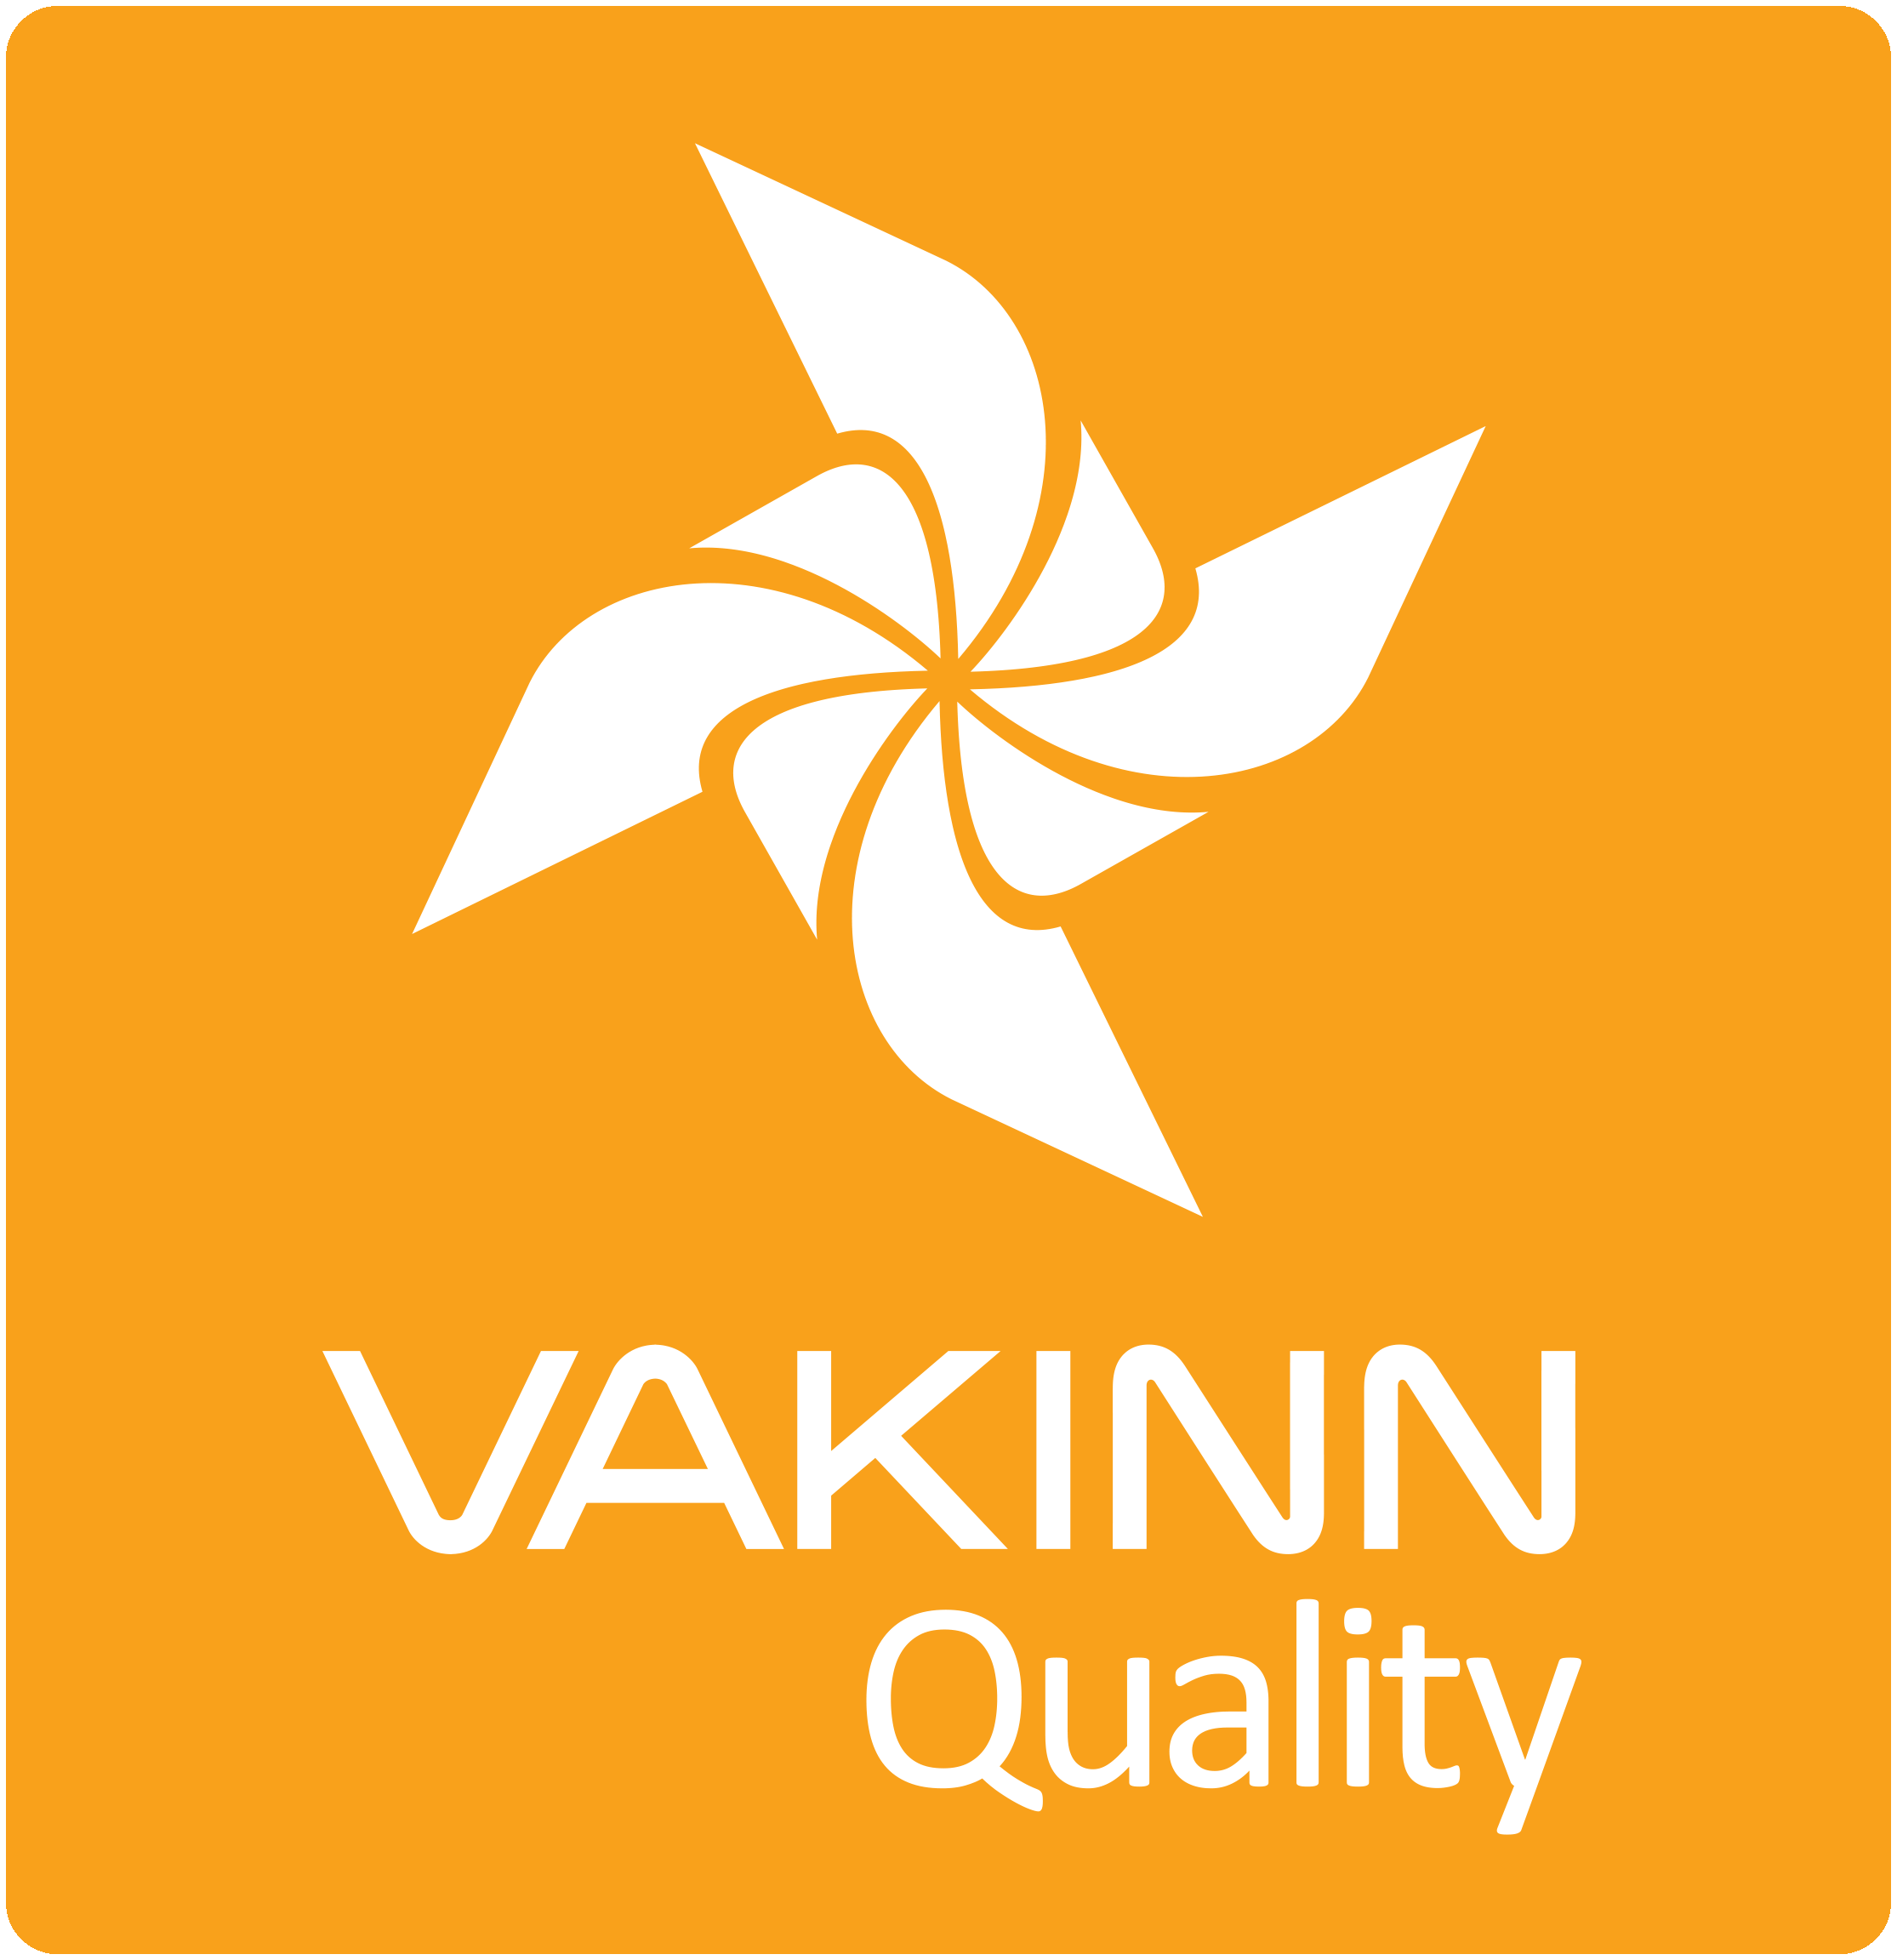

Vakinn Code of Ethics

All companies participating in Vakinn must confirm and abide by the Vakinn Code of Ethics:

- The company provides its customers with courteous and reliable service.
- The company maintains and respects confidentiality and discretion in all customer relations.
- The company is guided by professionalism, honesty and fairness in all communications and business transactions.
- The company treats all its customers with equal respect and consideration regardless of e. g. gender, origin, culture, sexual orientation, religious preferences, age, social standing and physical aptitude.
- The company ensures that all information provided to its customers is correct and that its
advertising provides a truthful and reliable impression of its services and facilities.
- The company prices goods and services unambiguously and in compliance with current legislation.
- The company makes an effort to answer all enquiries and requests professionally and efficiently.
- The company guarantees a fair and prompt handling of complaints.
- The company upholds and observes all laws and regulations pertaining to its operation.
- The company ensures that its bookkeeping and accounting is conducted in a professional manner.
- The company meets all its responsibilities towards employees by observing current laws and collective labour agreements.
- The company ensures that all its employees receive proper training and that working conditions are appropriate.
- The company ensures the safety of its employees and customers by means of professional work practices and by maintaining high standards of facilities and equipment.
- The company demonstrates responsibility towards Iceland’s nature, environment and society.
- The company upholds the interests and reputation of Iceland as a high quality destination, emphasising professionalism, hospitality, excellent service and sustainability.

One example is sufficient along with a confirmation that contracts are in place for all members of the staff. Personally identifiable information should be avoided.
One example is sufficient along with a confirmation that such documents exist for all employees.
Photo/s required.
The criteria in chapter four apply to the bronze label of the environmental certification. If the company requests silver or gold certification, the applicable environmental criteria no. 300 must be fulfilled.
See checklist on vakinn.is.
Photo/photos must be submitted along with written instructions.
Valid from 1.1. 2024.

