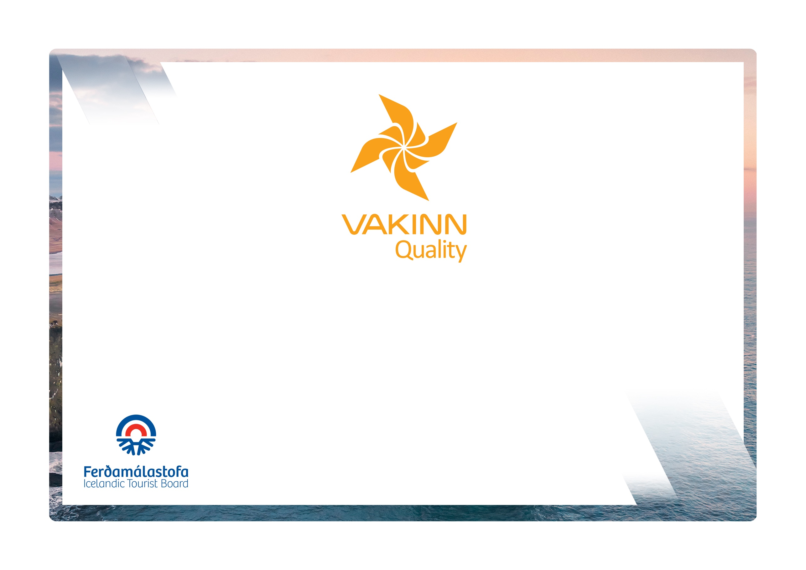
Specific Quality Criteria no. 227
5th edition 2022
Helicopter Tours
vakinn.is

Quality and Environmental Certification
On the Way to Sustainable Tourism

The following quality criteria are filled out by a company representative. A clear explanation of how each applicable criterion is fulfilled must be given with reference to appropriate documentation, e. g. employee handbook/quality manual, safety plans, photos etc. Random and/or selected criteria will be verified by the auditor.
227-1 | Safety | Yes | N/A | How fulfilled/explanation
227-1.1 | For each type of tours there is an itinerary (written description) including a description of routes, schedule and other trip arrangements.
227-1.2 | A checklist has been compiled for safety equipment on tours and excursions, including f.ex.:  - First aid kit/equipment.  - Communication devices.  - Tracking devices.  - Extra clothing.  - Other equipment according to conditions on each tour.
227-1.3 | Pilots receive training in selection of landing sites, off helipads, in order not to endanger the safety of passengers, especially in the wilderness and on glaciers.
227-1.4 | Pilots/guides receive training in how to provide information to passengers and how to support passenger comfort and well-being.
227-1.5 | There is a checklist for pilots/guides on the safety matters* that are covered with customers before and during the tour, e. g. regarding:  - Local conditions and weather.  - Schedule.  - Proper use of safety equipment.  - Appropriate clothing.  - Safety precautions on or near glaciers, rivers ad steep slopes.  - Other, depending on conditions on each tour.
227-2 | Environment | Yes | N/A | How fulfilled/explanation
227-2.1 | The company complies with Icelandic and international laws and regulations on environmental protection.
227-2.2 | The company has compiled and published a code of conduct in order to minimize disturbance from its operations so that neither the experience of others is diminished nor plants or animal life harmed.
227-2.3 | The company ensures that all pilots have practical knowledge of and understand the booklet „Fly Neighbourly Guide“.
227-2.4 | Pilots/guides ensure that neither they themselves nor the customers are subject to excessive disturbance from loud engine noises.
227-2.5 | The company ensures that visible signs of its operations in natural environments are kept to a minimum.
227-2.6 | The company consults with organisations in charge of conservation in the areas, in which the company operates, at least once a year.
227-2.7 | The company consults with landowners when operating on their land, for example on where, when and how often tours take place.
227-2.8 | All equipment and waste are removed. The company ensures that no permanent traces/damages are seen in the nature in connection with the company‘s tours or activities.
227-2.9 | Customers are informed about toilet arrangements where conventional facilities are not available.
227-2.10 | Helicopters are cleaned and disinfected on the inside according to written cleaning plans.
227-2.11 | Customers are reminded of responsible travel behaviour.

227-3 | Education and Training | Yes | N/A | How fulfilled/explanation
227-3.1 | Pilots/guides have completed specialized training and have experience appropriate for the tour in question.
227-3.2 | Pilots/guides have completed the course Wilderness First Aid (Fyrsta hjálp 1, 20 hours) from ICE-SAR or a comparable course from another organisation and attend a refresher course (4 hours) every two years.
227-3.3 | Pilots/guides in tours that include landing in the wilderness ** have completed the course Wilderness First Responder (WFR) from ICE-SAR, or a comparable course from another organisation, and attend a refresher course every three years.
227-3.4 | Pilots/guides have received instructions regarding safety and responsible conduct on glaciers and mountains. This is done according to a written procedure that covers both content and execution of the instruction.
227-3.5 | Pilots/guides on tours that involve landing on glaciers receive appropriate instructions and training in crevasse rescue at least once a year.
* This refers to safety aspects on the ground before the flight and at the places of landing.
** Wilderness is a place or area where it takes at least two hours to get assistance/rescue from first responders by land.

