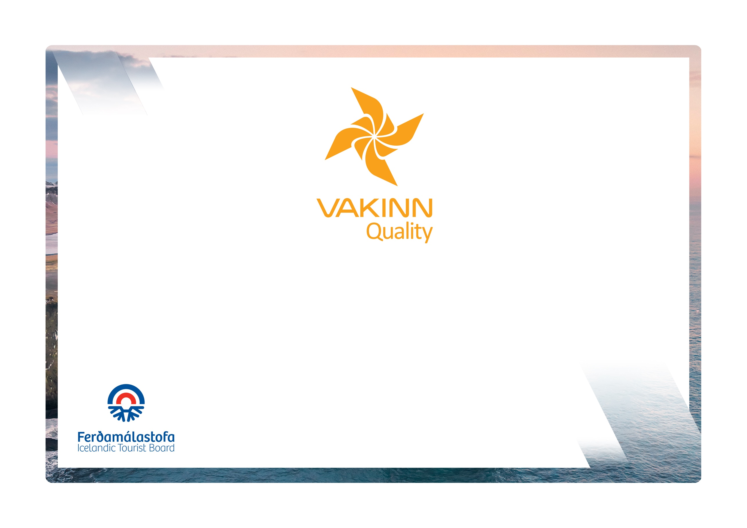

Restaurants and Cafés

Quality and Environmental Certification
On the Way to Sustainable Tourism

Specific Quality Criteria no. 224
4th edition 2022
vakinn.is

The following quality criteria are filled out by a company representative. A clear explanation of how each applicable criterion is fulfilled must be given with reference to appropriate documentation, e. g. employee handbook/quality manual, safety plans, photos etc. Random and/or selected criteria will be verified by the auditor.
224-1 | Facilities and Hygiene | Yes | N/A | How fulfilled/explanation
224-1.1 | Entrance and immediate vicinity are clean and tidy.
224-1.2 | Buildings and facilities have been checked regarding accessibility for all (i. e. for all age groups, persons with restricted mobility, visual or hearing impaired etc.).
224-1.3 | Furnishings and tables are arranged in a way that minimises disturbance from e. g. guests waiting for service, passage of employees or cold air.
224-1.4 | Coatracks are available.
224-1.5 | Tables and chairs are in very good condition.
224-1.6 | Minimum table size is 0.50x0.30 m per guest.
224-1.7 | Tables and tablecloths are clean and in good condition.
224-1.8 | Table decorations, condiment sets (salt, pepper, oils etc.) and other items on customers’ tables are kept clean and in proper condition.
224-1.9 | Tables, contact surfaces, menus, condiment sets etc. are disinfected after each guest/family/group.
224-1.10 | Reminders on personal hygiene and infection prevention measures i. e. hand washing and sanitizing are visible to guests and employees.
224-1.11 | If a buffet is offered, special arrangements are made regarding disinfection and infection prevention.
224-1.12 | Used tableware must not be stored or stacked in the dining area.
224-1.13 | Employees are presentable and dress in clean and appropriate working attire.
224-1.14 | Toilets are marked, clean and in very good condition.
224-1.15 | Active internal control system is in place cf. current laws and regulations on food safety and according to the directions of the Icelandic Food and Veterinary Authority.
224-2 | Service | Yes | N/A | How fulfilled/explanation
224-2.1 | Opening hours are advertised e. g. in the window or on the company’s web page.
224-2.2 | Menu including price list is clearly displayed at the entrance.
224-2.3 | Menus are neat and legible in an appropriate format in at least one language besides Icelandic.
224-2.4 | The menu displays prices of food and drinks as well as information on volume per glass or bottle of beverages.
224-2.5 | Employees are familiar with courses on the menu and can assist guests with their choices.
224-2.6 | Products from the local area are used as much as possible. The origin must be known and explained to guests.
224-2.7 | Effort is made to purchase products and raw materials produced in Iceland, organic products and Fairtrade products, e. g. coffee tea, cocoa and sugar.
224-2.8 | Employees have knowledge of the wine selection and other beverages on offer and can assist guests in making their choices.
224-2.9 | Employees are aware of service timing and avoid unnecessary delays or excessive haste when serving guests.
224-2.10 | Children’s needs are taken into consideration, e.g. by offering children’s portions and highchairs.
224-2.11 | Guests’ special requests regarding food intolerance and food allergies are responded to.
224-2.12 | Written guidelines, regarding the choice and volume of music in the dining area, are in place. The guidelines are introduced to all employees.
224-3 | Beverages | Yes | N/A | How fulfilled/explanation
224-3.1 | Wine is offered by the glass; with a choice of at least two types of each, red and white.
224-3.2 | The restaurant offers a wide selection of beer.
224-3.3 | Common varieties of strong liquor are on offer.
224-3.4 | Accredited measures are used for measuring correct volume of strong drinks.
224-3.5 | Various types of coffee are on offer, such as cappuccino, espresso and café latte.
224-3.6 | Various kinds of tea are on offer.
224-4 | Education and Training | Yes | N/A | How fulfilled/explanation
224-4.1 | At an “a la carte“ restaurant* the chef has completed a journeyman‘s examination in culinary art (valid from January 1st 2026).
224-4.2 | At an “a la carte“ restaurant* the head waiter has completed a journeyman‘s certificate in waiting (valid from January 1st 2026).
224-4.3 | Kitchen and service employees have received teaching and training in the handling of food according to Vakinn course descriptions or comparable. A written description on how this is performed and what is covered is available.
224-4.4 | Employees have received teaching and training in the importance of hygiene and cleaning according to Vakinn course descriptions or comparable. A written description on how this is performed and what is covered is available.
224-4.5 | Service employees have received teaching and training in the reception of guests and waiting tables according to Vakinn course descriptions or comparable. A written description on how this is performed and what is covered is available.
224-4.6 | At least one member of the kitchen staff has completed a course on food intolerance and food allergies.
224-4.7 | (Service) employees attend a refresher course in initial reactions to suffocation and anaphylaxis.
* A la carte restaurant offers the choice of at least three starters, three main courses and three desserts.

