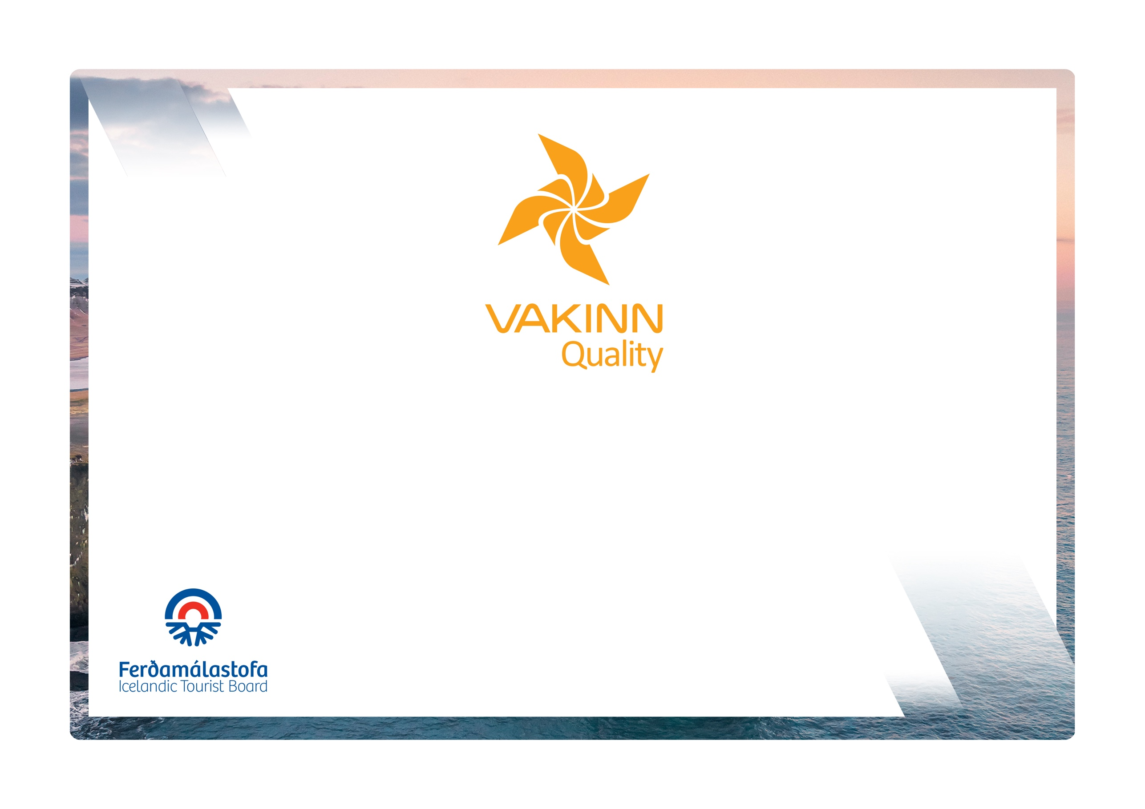

Museums, Centres and Exhibitions

Specific Quality Criteria no. 213
5th edition 2022
vakinn.is
Quality and Environmental Certification
On the Way to Sustainable Tourism

The following quality criteria are filled out by a company representative. A clear explanation of how each applicable criterion is fulfilled must be given with reference to appropriate documentation, e. g. employee handbook/quality manual, safety plans, photos etc. Random and/or selected criteria will be verified by the auditor.
213-1 | Service and Operational Practices | Yes | N/A | How fulfilled/explanation
213-1.1 | Opening hours are clearly advertised.
213-1.2 | Buildings and facilities have been checked regarding accessibility for all (i. e. for all age groups, persons with restricted mobility, visual or hearing impaired etc.).
213-1.3 | Manager and/or service provider is familiar with current Acts and Regulations on archaeology and artefacts relevant to the operation.
213-1.4 | Protection is kept in high regard and the protection of cultural artefacts is emphasised as a key factor in all operations cf. the current Act on Protection of Cultural Heritage. This applies to tangible as well as intangible facets of cultural heritage. This implies among other:  - Meticulously define the value of the place/artefact/factor from a cultural-history point of view.  - To raise interest and awareness in communities/societies or among others with vested interest by consulting with them.  - Cooperating with specialists on developing a conservation plan/strategy that complies with current laws and recognised conservation practices (e.g. laws and regulations on the conservation of cultural heritage).
213-1.5 | Those in charge of museums must abide by laws and recognised working methods pertaining to museum operations (see e.g. Current Act on Museums and ICOM‘s Code of Ethics).
213-1.6 | Information is accessible and clearly presented in at least two languages, one of them Icelandic.
213-1.7 | An effort is made to ensure that all presentation is professional, diverse and of high quality, suitable for diverse groups.
213-1.8 | The content of exhibitions, presentations and dissemination are reviewed on a regular basis in consultation with specialists and authorities within the relevant field.
213-1.9 | The history and the relevant topic are held in high regard, keeping in mind integrity, authenticity and truthfulness in all presentation.
213-1.10 | An effort is made to offer lively and interactive presentations, e.g. guided tours, events, etc.
213-2 | Education and Training | Yes | N/A | How fulfilled/explanation
213-2.1 | Employees have specialist education, e.g. are specialists in the appropriate field, certified guides and/or experienced in the field of history, culture and nature.
213-2.2 | Employees have knowledge of the museum's exhibits, the culture history and nature related to the museum and can provide relevant information. (This is included in written procedures for training and orientation of new employees).

