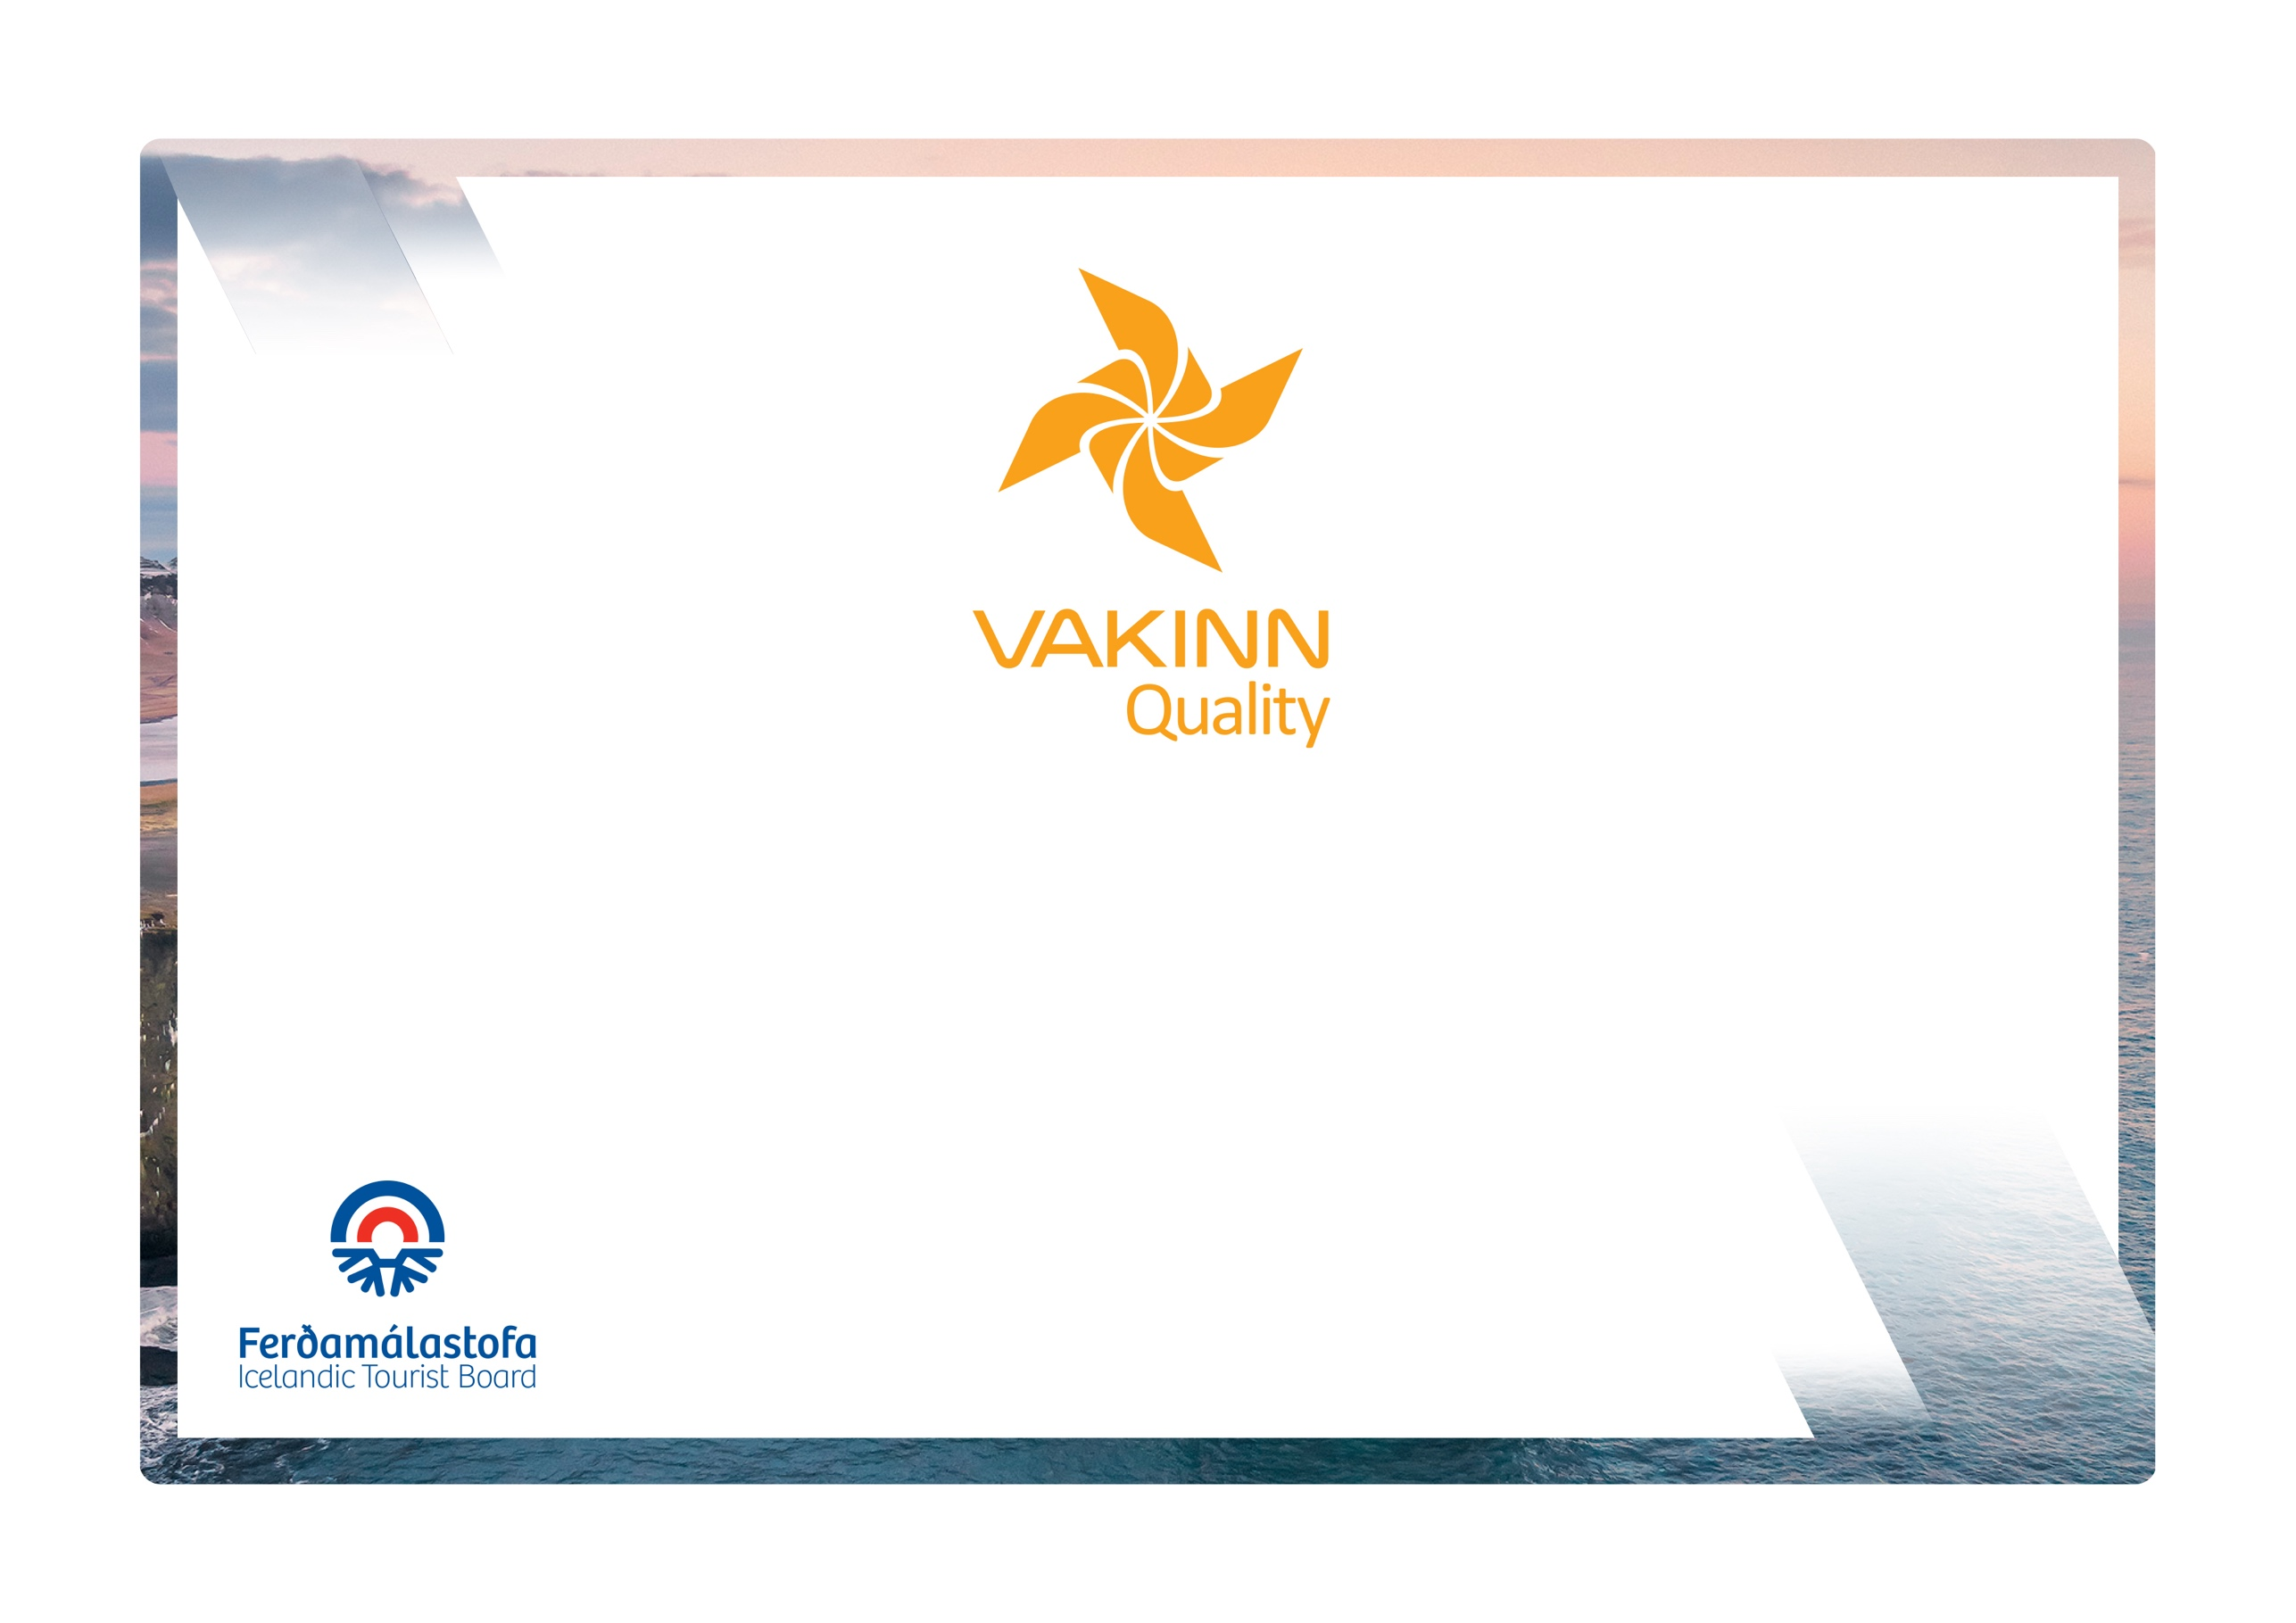

a
vakinn.is

Quality Criteria for Campsites

4th edition 2023

Quality and Environmental Certification
On the Way to Sustainable Tourism

Gæðaviðmið fyrir tjaldsvæði
Gæðaviðmið fyrir tjaldsvæði

4. útgáfa 2023
Bílaleigur

vakinn.is
Gæða- og umhverfisvottun ferðaþjónustunnar
Á leið til sjálfbærrar ferðaþjónustu

Table of Contents

1. Immediate surroundings 3
1.1. Exterior appearance 3
2. Safety 3
2.1 Lighting, fire prevention and more 3
3. Service building 4
3.1 Facilities and furnishings 4
3.2 Various services 4
3.3 Leisure/recreation 5
4. Shared bathroom and toilet facilities 5
5. Common areas 7
5.1 Sites for campers, caravans and tents 7
5.2 Outdoor facilities for cooking and/or having meals (if applicable) 8
5.3 Indoor facilities for cooking and/or having meals (if applicable) 8
6. Hygiene and cleaning 9
7. Education and training of employees 9
8. Accessibility for the disabled 10

The following quality criteria are filled out by a company representative and sent to the auditor along with other documents. A clear explanation of how each applicable criterion is fulfilled must be given with reference to appropriate documentation, e. g. employee handbook/quality manual, safety plans, photos etc. Random and/or selected criteria will be verified by the auditor. Quality criteria marked (N) are new from previous edition.
Criteria marked in red are minimum requirements and must be fulfilled.
Immediate surroundings |  |  | Yes | No | How fulfilled/explanation

1.1. Exterior appearance
1.1.1 |  | All signs, markings and flags are in good condition.
1.1.2 |  | Outdoor lighting is sufficient, e.g. at parking lots, sidewalks, steps, entrances, etc. Careful attention is paid to the maintenance of these areas all year round.
1.1.3 |  | Inviting outdoor premises e.g. sheltered areas (separated area; a porch or terrace), garden furniture, and flower beds/pots etc.
1.1.4 |  | Wind breaks (fences or trees/bushes) shelter and demarcate the campsite.
1.1.5 |  | Charging stations for electric cars are available for guests on site. (N)
Safety |  |  | Yes | No | How fulfilled/explanation

2.1 Lighting, fire prevention and more
2.1.1 |  | The site is demarcated/fenced.
2.1.2 |  | Traffic is limited at night (between 23:30 and 07:00).
2.1.3 |  | Sufficient lighting by the service house.
2.1.4 |  | Sufficient lighting on paths, by car parks and outside washing facilities.
2.1.5 |  | Clear information on appropriate safety issues e.g. 112 emergency number etc. prominently displayed e.g. on an information board (in at least Icelandic and English).
2.1.6 |  | GPS coordinates of the campsite prominently displayed.
2.1.7 |  | Fire extinguishers are on site, tested reglulary and staff trained to use them. Clear operating instructions and location marked on an information map of the site.
2.1.8 |  | Smoke detectors are in place in the service building (and by cooking facilities, if applicable). They are tested regularly.
2.1.9 |  | Fire blanket is in place by the cooking facilities, if applicable.
2.1.10 |  | First aid kit is in place in service building, checked and restocked regularly.
2.1.11 |  | A defibrillator is on site.
Service building |  |  | Yes | No | How fulfilled/explanation

3.1 Facilities and furnishings
3.1.1 | Furniture, equipment and fixtures are in good condition, minimum signs of wear and tear.
3.1.2 | Good lighting indoors.
3.1.3 | Clear rules on smoking on the premises are prominently displayed.
3.1.4 | Clear rules regarding pets are prominently displayed.
3.1.5 | Television.

3.2 Various services
3.2.1 | House rules for the campsite are prominently displayed in the service building/reception and in promotional materials e.g. web site (including rules on pets, opening times, fees, quiet hours, vehicle traffic etc.).
3.2.2 | Wireless internet access is available in the service building.
3.2.3 | Map of the campsite with information on services available and location is visible to guests outdoors, e.g. in a service building/reception window.
3.2.4 | Safetravel information screen is on site.
3.2.5 | Food products /small merchandise is on sale
3.2.6 | Toiletries e.g. toothbrushes, toothpaste, sanitary napkins, shaving equipment, shampoo etc. are on sale.
3.2.7 | A washing machine is available for guests.
3.2.8 | A drying cabinet/dryer is available for guests.
3.2.9 | Luggage storage is available for guests
3.2.10 | Valuables can be kept in a locked cupboard in the service building.

3.3 Leisure/recreation
3.3.1 | Facilities for leisure activities e.g. table top football, billiard, etc.
3.3.2 | Outdoor play equipment is available.
3.3.3 | Hot tub with safe access is available on site. Information and guidelines for guests are clearly displayed.
3.3.4 | Bicycles can be rented on site.
Shared bathroom and toilet facilities |  |  | Yes | No | How fulfilled/explanation
4.1 | Shared bathroom facilities are clearly identified and open 24 hours.
4.2 | Floors, walls and ceilings are clean and in good condition.
4.3 | Interiors and equipment are in good condition.
4.4 | Windows have opaque glass, film or curtains to ensure guest privacy.
4.5 | Air conditioning, fan or windows that can be opened.
4.6 | Where more than one shower is in the same room, they must be separated by a partition.
4.7 | Clothes hooks or other facilities for hanging clothes are available.
4.8 | Hægt er að læsa salernis- og sturtuhurðum innan frá. WCs and bathrooms/showers can be locked from the inside.
4.9 | At least one wash basin per 30 guests.
4.10 | There is good lighting at wash basins.
4.11 | Handsoap.
4.12 | Disposable towels.
4.13 | Toilet paper in reserve.
4.14 | Wastebasket.
4.15 | Mirror by the wash basin.
4.16 | Shelf or side table.
4.17 | Electrical socket by the mirror.
4.18 | - One fully equipped bathroom for 25 guests, taking into account  needs of disabled people.  - Two additional toilets (wc) if there are 26-100 guests.  - For every 50 guests over 100, there must be one additional toilet, etc. (N)
4.19 | At least one shower for every 50 guests.
4.20 | Slip prevention in shower.
4.21 | Safety handles in or by the shower.
4.22 | - Campsites for up to 25 guests have at least one wash basin.  - At least two wash basins for 26 to 100 guests.  - Maximum 50 guests per wash basin.
4.23 | Electric hand dryers.
4.24 | Hairdryer is available.
4.25 | Facilities for babies f.ex.for changing diapers.
4.26 | High chair is available.
Common areas |  |  | Yes | No | How fulfilled/explanation

5.1 Sites for campers, caravans and tents
5.1.1 | Separate area for tents (not accessible for motorised vehicles).
5.1.2 | Well-marked and maintained area for the disposal of garbage.
5.1.3 | Waste sorting containers are clearly marked and with lids. (N)
5.1.4 | Information available about the nearest disposal unit for sewage.
5.1.5 | Spacious, well-marked and numbered sites for trailer tents, pop up campers, caravans and campers.
5.1.6 | Huts for rent (sleeping only).
5.1.7 | Huts for rent (with individual kitchen-, bathing and toilet facilities).
5.1.8 | Access to electricity available (at least 10 amps).
5.1.9 | At least 10 sockets per 20 camping spaces (at least 10 amps).
5.1.10 | Facilities on site for the disposal of sewage operated by the site managers.

5.2 Outdoor facilities for cooking and/or having meals (if applicable)
5.2.1 | Tidy/well maintained picnic tables.
5.2.2 | Outdoor sink with cold water.
5.2.3 | Waste sorting bins are clearly marked and with lids (N).
5.2.4 | Outdoor barbeque is in good condition. Appropriate instructions available.
5.2.5 | Sheltered (under roof) and well maintained area with an outside barbeque in good condition. Appropriate instructions for guests available.
5.2.6 | Tidy/well maintained picnic tables and chairs under roof. Secured against wind.
5.2.7 | At least one sink for dishwashing per 50 guests, indoors or outdoors, hot and cold water.

5.3 Indoor facilities for cooking and/or having meals (if applicable)
5.3.1 | Window curtains (fabric, blinds, screen, film or sun protection glass) where needed.
5.3.2 | Sink with plug, hot and cold water. Dishwashing brush, dish washing liquid and dish rack.
5.3.3 | Good lighting.
5.3.4 | Ventilation, fan or a flip up/hinged window.
5.3.5 | Waste sorting bins are clearly marked and with lids (N).
5.3.6 | Fire blanket and extinguisher.
5.3.7 | Smoke detector.
5.3.8 | Gas detector, if applicable.
5.3.9 | Clear house rules prominently displayed.
5.3.10 | High chair.
5.3.11 | At least one cooking hob (two plates) per 75 guests.
5.3.12 | Two or more sinks with plug, hot and cold water. Dishwashing brush, dish washing liquid and dish rack.
5.3.13 | Dish towels and tea cloths/dish rags (changed daily).
5.3.14 | Worktops.
5.3.15 | Kettle/water boiler.
5.3.16 | Tableware: Soup bowls and flat plates, knives, forks, spoons, dessert spoons, water goblets, coffee cups/mugs
5.3.17 | Kitchen utensils: cutting boards, knives, cheese slicer, stirring spoons/spatulas, can opener, cork screw.
Hygiene and cleaning |  |  | Yes | No | How fulfilled/explanation
6.1 General hygiene
6.1 | Very high standard of cleanliness: Minimal signs of discoloration or lime scale on wash basins, WCs, showers/bathing facilities, no dirt in corners, drawers, behind radiators etc.
6.2 | Daily checking/cleaning of all public areas such as shared cooking and dining facilities, service building/reception, laundry facilities.
6.3 | Public bathing and toilet facilities cleaned at least daily (NB particular attention given to peak hours), garbage removed, soap and paper dispensers.
6.4 | Outside area checked, tidied and garbage bins emptied daily.
Education and training of employees |  |  | Yes | No | How fulfilled/explanation
7.1 | Employees receive training in cleaning procedures and in reception of guests. Written description, on how this is performed and what is covered, is available.
7.2 | Reception employees receive information about the local environment, e.g. history, culture, recreation and events so they can provide reliable information. Written description on how this is performed and what is covered is available. (N)
7.3 | Employees who do not speak Icelandic are encouraged and supported to learn Icelandic. This is addressed in training for new employees. (N)
Accessibility for the disabled |  |  | Yes | No | How fulfilled/explanation
8.1 | The company participates in the project Accessible Tourism, run by the Icelandic Tourist Board, and has confirmed that minimum criteria regarding accessibility for the disabled is fulfilled. (N)
8.2 | The company participates in the project Accessible Tourism, run by the Icelandic Tourist Board, and has confirmed that minimum criteria regarding accessibility for the visually impaired and the blind is fulfilled. (N)
8.3 | The company participates in the project Accessible Tourism, run by the Icelandic Tourist Board, and has confirmed that minimum criteria regarding accessibility for the hearing impaired and the deaf is fulfilled. (N)

