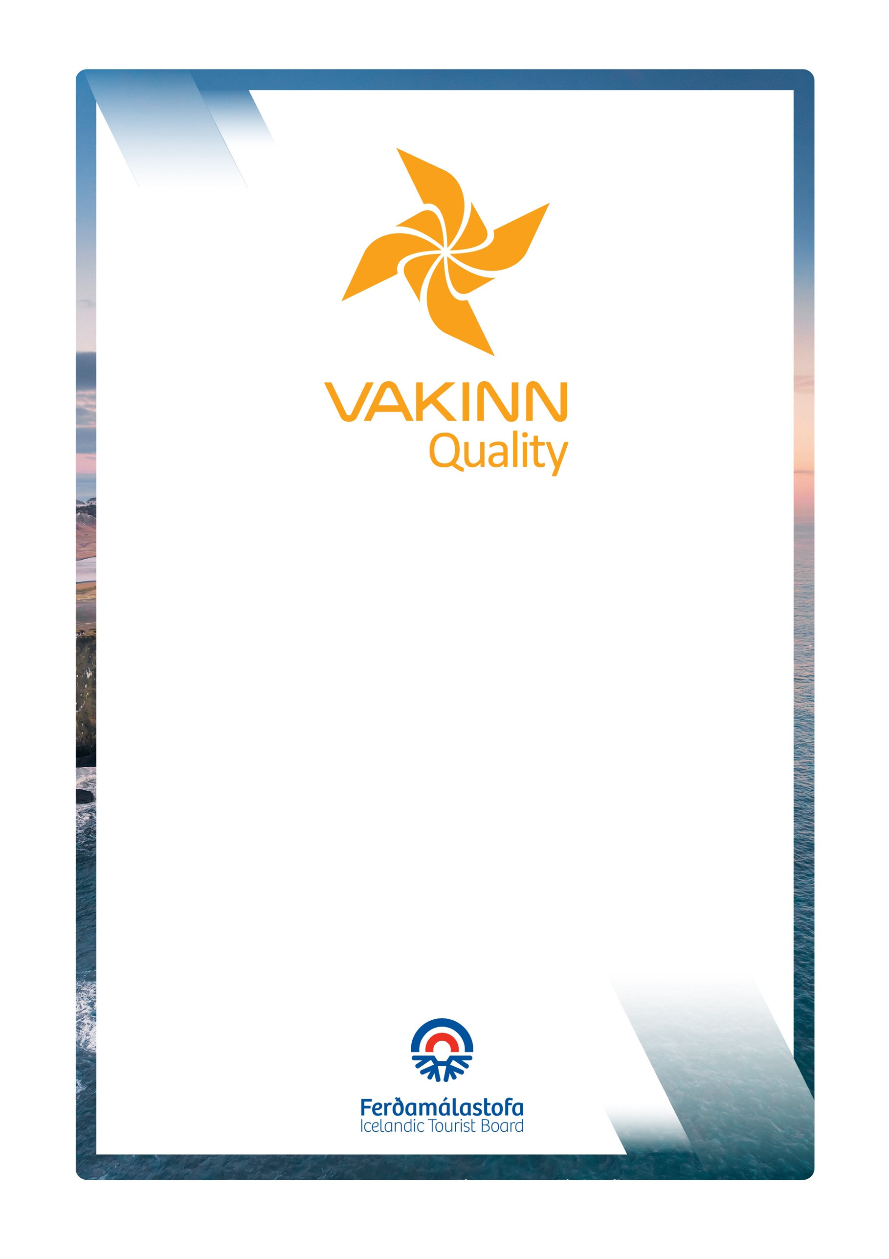
Quality and Environmental Certification
On the Way to Sustainable Tourism

vakinn.is

Tourism Services other than Accommodation
With guidance and explanations
no. 200
5. útgáfa 2022
General Quality Criteria
Gönguferðir í dreifbýli, óbyggðum
og í fjalllendi við sumaraðstæður

Sértæk gæðaviðmið nr. 200
5. útgáfa 2022
VAKINN – Gæða- og umhverfisvottun ferðaþjónustunnar
Á leið til sjálfbærrar ferðaþjónustu

vakinn.is

Following criteria, if applicable, must be fulfilled. Documents and/or photos are required as a confirmation on how the criteria is fulfilled.
1. Website and Information
200-1.1 | The company has a website and / or page on social media with credible images and detailed information that is updated regularly.  Guidance / explanations  The auditor evaluates the company's website with this in mind. If a website does not exist, it is sufficient for the company to have a page on social media, e.g. on Facebook. All information needs to be accurate and updated as needed.
200-1.2 | Photos and information on the company´s website and in other promotional material show responsible behaviour towards nature. The company encourages customers to travel responsibly.  Guidance / explanations:  The auditor views the website with this in mind. The presentation of marketing material should show respect for the nature. It is for example not satisfactory to publish pictures of off-road driving or people in dangerous situations in the nature. Furthermore, it should be avoided to show people traveling through sensitive nature.  If marketing or other digital material used on the company's website and social media is taken with a drone of any size, it must be ensured that permission for photography/filming has been obtained where needed, regardless of whether the content was created by the company or by any other party. This applies e.g. in protected conservation areas such as nature reserves, monuments and national parks, as well as urban areas subject to drone regulations. This also applies to private land where drones are prohibited. Such permits are issued by the Environmental Agency, Vatnajökull National Park, Þingvellir National Park, Transport Authority and private landowners in the interests of environmental protection, wildlife protection, public safety, data protection and positive visitor experience.  Encouragement for responsible travel behaviour can be found on the company's website e. g. in connection with environmental or sustainability policy and / or in the guides procedures. Customers can f. ex. be made aware of The Icelandic Pledge published by Íslandsstofa (Visit Iceland), where special emphasis is placed on encouraging tourists to travel responsibly around Iceland.
200-1.3 | The Vakinn logo and a text about the certification is prominent on company’s website and in other promotional materials (applicable for Vakinn-certified companies).  Guidance / explanations:  The auditor verifies the company's website specifically, with this in mind.  Companies that complete certification receive Vakinn's logos with a certification number. The logo must be published on the company’s website and in promotional material. There should also be information about the certification in text on the website. Certified companies should have a link on Vakinn's logo that refers to Vakinn's website.
200-1.4 | It is clearly stated on the company´s website and in other promotional material:  - If the service (or parts of it) is performed by a partner.  - What is included in the price.  - Terms and conditions concerning confirmation fee, cancellations of a trip or order, customer´s absence (now show) and/or refund.  Guidance / explanations:  The auditor checks the company's website and evaluates these aspects.  Itineraries must state if a partner carries out part of the trip or even the entire trip. Example: A travel agency that offers a package tour in the south, where customers go on a horse-riding tour with company X and a snowmobile tour with company Y. In this case, such an arrangement must be clear to customers.  In the itinerary / terms it must be clear what is included in the price of the trip or service and what is not. E. g. guidance, accommodation, driving, flights, meals, entertainment and equipment.  Terms must be clear and clearly visible on the website.
200-1.5 | When booking tours / recreation, customers receive detailed information, e. g. about the following:  - Appropriate protective clothing and equipment.  - Difficulty level of tour / recreation.  - Age limit (if applicable).  - Duration / schedule of tour / recreation.  Guidance / explanations:  This information can be found on the company's website, but if not, the auditor needs to see a confirmation that customers receive this information in another way.  When customers book a trip, it is important that they receive detailed information about the trip so that they can best prepare for it.  The information should be appropriate for the tour in question. It is necessary to state which protective clothing is best suited and whether and what equipment customers need to bring with them, e. g. backpacks, walking sticks, packed lunches, drinks etc.  It is important to mention the level of difficulty of the trip and the duration. If e. g. in the case of a walking tour, it must be stated how long the trip is (kilometres), duration of the trip, ascent, surface (whether walking on paths), whether it is necessary to cross rivers etc.  If the conditions on the trip are very demanding, it may be necessary to set an age limit for participating in the trip.
2. Management and Human Resources
200-2.1* | Specific quality criteria, applicable to the operation, have been filled in. F. ex. horse riding tours, hiking, travel agencies, car rentals etc.  Guidance / explanations:  The auditor examines the company's operations, i.e. information on tours, recreation and services advertised on the company's website regarding which specific quality criteria apply to the operations. The auditor and the company's representative then make a joint assessment of which specific criteria apply.  The company representative submits the relevant specific quality criteria which are reviewed by the auditor. The criteria must be well and carefully completed, with explanations where necessary, e. g. refer to other submitted data f. ex.: "See p. 8 in the Quality Manual/Staff Manual" or "see annex to the Staff Manual" or other explanations. Examples of completed specific criteria can be found on Vakinn's website under help material.  If the criteria are not sufficiently completed (items omitted or explanations missing), the auditor will call for further documentation or explanations. All relevant criteria must be fulfilled. If the requirements of the specific quality criteria do not apply, this box must be marked with the appropriate explanations.
200-2.2* | An employee- and/or quality manual has been compiled covering f. ex.:  - The company´s strategy.  - Vakinn´s quality and environmental certification (applies after the company has received certification).  - Vakinn´s Code of Conduct.  - Safety plans.  - Environmental- or sustainability policy.  - The company's emphasis and rules regarding the natural environment and responsible travel behaviour.  - Occupational safety.  - Service, communication and procedures.  - How to answer inquiries.  - How to receive and handle complaints.  - Cleaning plans and infection prevention.  - Rules on uniforms/attire, cleanliness and personal hygiene.  Guidance / explanations:  An employee handbook / quality manual must be sent to the auditor who evaluates the content. It is important that all the above points are stated regardless of the size of the company, but it is natural that the scope of the employee / quality manual is greater in larger companies. The auditor examines the manual to see if there is a discussion of these issues in it.  You can find various help materials and examples on Vakinn's website that can be useful to companies in creating a quality manual.  - The company's strategy and value: The quality manual must include a review of the company. The coverage depends on the scope and size of the company. The company's policy and values ​​should be stated along with e.g. goals and priorities.  - Vakinn's quality and environmental certification: The quality manual must include a brief discussion of the certification. E.g. what Vakinn is, when the company received certification, what is involved in the certification and its value for the company.  - Code of Ethics: The company must have established a code of ethics that employees know and work by, e.g. to ensure responsible and professional practice. There is a special code of conduct that companies with Vakinn certification have agreed to work according to, see here.  - Safety plans: It is crucial that the company's employees and those who perform services in the company's name are familiar with its safety plans and work in accordance with them. Furthermore, it is highly recommended to offer staff involvement in the preparation and review of safety plans. For more information, see 200-3.1.  - Environmental policy and / or sustainability policy: Companies can have both, an environmental and sustainability policy or either one depending on the company's priorities and what the company's activities are. See instructions and discussion on Vakinn's website. See also additional material for the checklist Towards Sustainable Tourism.  - The company's emphases and rules regarding behaviour in the nature and responsible travel behaviour: Information concerning sensitive nature, responsible travel behaviour and the company's emphases must be clear and staff must be informed about them. The guides' procedures should include that they inform customers about responsible travel behaviour e.g. at the beginning of each trip.  - Occupational safety: The company's occupational health and safety focus must be covered in the employee / quality manual. What is the company's occupational safety policy, what is being done to ensure a good, safe and healthy work environment for employees? All employers have a legal obligation to make a written plan for health and safety at work, regardless of the size of the workplace. See more information on Administration of Occupational Safety and Health  - Services, communication and procedures: In Vakinn's guide to customer service, which can be found on Vakinn's website, you can find various instructions that can be useful, e.g. discussion of quality policy, response to inquiries and reservations, etc.  - Receipt and handling of complaints: In Vakinn's guide to customer service, there is a section on how to handle complaints .  - Cleaning plans and infection prevention. All companies should have a cleaning plan (cleaning rules) which clearly states what to clean, how, how often, with what and who is responsible. In the wake of the Covid-19 pandemic, companies should pay special attention to this with an increased emphasis on cleaning and infection prevention to increase customer and visitor safety. Special attention must be paid to common contact surfaces. For more information, see 200-3.9. See also the project Clean & Safe on the Icelandic Tourist Board´s website.  - Rules on uniforms / clothing, grooming and personal hygiene. The company needs to set clear rules for the personal hygiene of employees and general grooming. If staff wear uniforms, there must be rules, e. g. that the uniform should always be clean and well-groomed. The same applies if uniforms are not available, then there must be rules for a neat dress code. Also rules on general grooming and personal hygiene of staff. In some cases, such rules may need to be quite detailed and instructive.
200-2.3* | The company complies with applicable laws. All relevant licences and permits are valid and visible for guests as appropriate. If the company has a licence from the Icelandic Tourist Board, the licence logo is visible on the company´s website and on other promotional material.  Guidance / explanations:  The auditor obtains confirmation that the relevant licenses are valid. A copy or photo of the license should be sent to the auditor who also examines whether a license logo from the Icelandic Tourist Board is visible on the company's website if such a license is required for the operation.  It is important that the company's representatives and employees know the laws and rules that apply to the company's operations. It is good to prepare a summary of all of them and have accessible e.g. in the quality manual.  The main licensors for tourism in Iceland are the following:  • The Icelandic Tourist Board issues licenses for travel agencies and day-trip travel agents.  • The Icelandic Transport Authority issues permits for transportation, whether by land, air or sea, rivers and lakes.  • District commissioners are responsible for issuing permits for restaurants and accommodation.  • The Health Inspectorate issues operating licenses for horse riding and such activities must be notified to the Food Administration (MAST), see here. Health inspections also provide operating licenses for accommodation, restaurants and public toilets.  • The Environment Agency of Iceland issues permits for off-road driving, projects in nature reserves, photography and filming in special areas, reindeer hunting and bird hunting.  • Chiefs of Police provide e. g. firearms license and parachute license.  • The Directorate of Fisheries issues licenses for recreational fishing.  In some cases, companies do not require a special permit for the operation, e.g. home accommodation and information centres are only subject to registration.
200-2.4* | The operation is run in accordance with the current Act on accounting procedures and pertaining regulations. The customer gets a receipt for purchased services, indicating, among other things, VAT and the seller´s name, identity number and VAT number.  Guidance / explanations:  The auditor must receive a copy of one receipt that meets these conditions. .
200-2.5* | Liability insurance from an insurance company is valid.  Guidance / explanations:  The auditor must receive a recent statement from an insurance company or a copy of the insurance.
200-2.6* | Written employment contracts/subcontracting agreements are drawn up for all employees and contractors.  Guidance / explanations:  The auditor shall be provided with at least one sample for each contract. The auditor may also request to see more such agreements in on-site and maintenance audits.  If an employee is hired for a period longer than one month, a written employment contract shall be made no later than two months after the start of work or employment confirmed in writing. Contractors' agreements are no less important, but they include e.g. information on the implementation of the work / service, contract period, working hours, payments, insurance, etc.  You can find an employment contract form, examples of contractor agreement and instructions for hiring employees on Vakinn´s website.
200-2.7* | Job descriptions, defining employees’ roles and responsibilities, are available for all positions.  Guidance / explanations:  At least one example must be sent to the auditor. He may request to see more job descriptions in on-site and maintenance audits.  See an example of waiter´s job description in Vakinn's manual.  See an example of a job description for a reception employee.
200-2.8* | Written procedures for training and orientation of new employees are in place.  Guidance / explanations:  The auditor examines and evaluates in writing a description of how this is done, e.g. in the company's quality manual. Guidelines and information can be found on Vakinn´s website, f.ex. information on human resources policy, job descriptions, employment contracts, employee reception, job training, job development and employee interviews. See also haefni.is
200-2.9* | All frontline employees carry nametags (or are otherwise identifiable) with their own name and/or the company name (uniform e. g. a light jacket, sweater or T-shirt).  Guidance / explanations:  The auditor receives a photo / photos. E.g. a photo of an employee in uniform and / or a photo of an identification card. This should also be examined in the on-site audit.
200-2.10* | The company maintains a list of staff / guides / contractors who work for or on behalf of the company with information that they have completed courses and received training in accordance with the requirements set out in specific quality criteria that apply to the company's operations (cf. 200-2.1). The list is updated regularly (at least annually).  Guidance / explanations:  The auditor receives the list of names. Names may be without ID number, father's name, etc. if personal information needs to be protected. This overview must include clear information about each and every employee's course, cf. those required in the chapter on education and training in specific quality criteria, that apply to the company.  The auditor examines the type and number of hours of first aid / first aid courses and checks that refresher courses are not older than approx. two years old.  Examples of courses that are repeatedly stated in requirements in specific quality criteria are the following: First Aid, Wilderness First Responder etc. Here it is the overall picture that is important, i.e. that in the group working for the company enough individuals who meet the educational requirements for the business can be found on the list. It is the company's responsibility to send guides / drivers with the right skills (including courses) to specific trips. An example of a list of names can be seen on Vakinn's website.
200-2.11* | There are written procedures for receiving, handling and preservation of complaints and feedback that staff (including guides) are familiar with.  Guidance / explanations:  These procedures should be in a quality manual sent to the auditor, cf. 200-2.2. It is important that the procedures are clear, efficient and responsible and that employees know their role. In addition to evaluating the rules of procedure, the auditor can also examine whether and how they are presented to employees, for example by talking to employees in the field audit.
200-2.12* | A manager (and/or an employee with managers support) is responsible for the company´s quality- and safety system according to Vakinn´s criteria. The knowledge of other key employees is guaranteed.  Guidance / explanations:  The auditor needs to receive information about the person / persons responsible for the quality and safety system and how other employees are made knowledgeable about this part of the operation.  It must be ensured that the company's operations are in accordance with Vakinn's quality and safety standards and that work is carried out in accordance with the procedure on which the certification is based. The person or group responsible ensures that the quality system is active by gathering information in an orderly manner, considering improvements and ensuring that work processes are in order and regularly reviewed. Discussion of this and clear procedures can be e.g. found in the company's quality manual. To maintain an effective quality system, managers and employees need to be well-informed, and by talking to general staff in the on-site audit, the auditor can gain insight into this.
3. Safety and Hygiene
200-3.1* | Safety plans for all services offered by the company have been compiled in Icelandic and English according to Article 11 of Act no. 96/2018 on the Icelandic Tourist Board. Responsible party is defined.  The safety plans are reviewed once a year and more often if needed, especially in the wake of accidents or other mishaps. Safety plans include the following:  - Risk assessment – a precise analysis of risks in the environment where a service is performed or goods are sold, that may potentially lead to accidents.  - Written work procedures – description of work procedures that should be followed to minimise risk of accidents.  - Contingency plan – how to respond in the case of accidents and/or mishaps.  - Incident report – registration of all irregularities, mishaps and/or accidents.  Guidance / explanations:  Safety plans for the services / trips presented on the company's website must be submitted. See instructions for making security plans on Vakinn's website.  The auditor reviews the safety plans and makes comments or approves if they are well prepared and satisfactory: It must be ensured that the safety plan contains the following:  Risk assessment: A form that can be accessed on Vakinn's website, but an auditor can also accept other types of data if the methodology is comparable.  Procedures: Describe the procedures thoroughly and include checklists e.g. equipment list, equipment handling, description of preparation for the trip, percentage of guides / customers, education and training of guides and drivers, etc.  Contingency plans: There can be one or more, but at minimum there should be a general contingency plan (description of the scene of the accident, the response of the response team, etc.)  Incident report: It must be clear that the company uses incident reports and that instructions are available to employees (guides and drivers).  It is mandatory that safety plans for tourism companies are available in both Icelandic and English. It is sufficient to send only the Icelandic version to the auditor, but if the staff / guides are English-speaking, confirmation must be sent that the data is also available in English. The auditor may request to see safety plans in English in the on-site audit.
200-3.2* | The company's safety plans are reviewed with staff / guides / contractors each year. There is a written procedure for how this is done.  Guidance / explanations:  The auditor requests information on how and when this has been done and can also verify in the on-site audit e.g. by talking to employees.  To maintain the knowledge of staff / guides / contractors, it is important to review the safety plans with them annually and each time they are updated. This can be done in various ways e.g. at staff meetings or through self-study of staff. If the latter option is chosen, the company must request a confirmation from staff that self-study has taken place.
200-3.3* | Guides / drivers confirm in the employment / contractor agreement that they have studied and work according to the company's safety plans.  Guidance / explanations:  The auditor examines one or two employment / contractor contracts.  The auditor can also examine this in on-site and maintenance audits, cf. 200-2.6.  To ensure the safety of customers as much as possible, guides and drivers must know the company's safety plans and act in accordance with them.
200-3.4* | In the case where a partner performs a service in the company’s name, the company gets a confirmation that safety plans from the partner in question have been compiled. This is done according to written procedures.  Guidance / explanations:  The auditor needs to verify that there is a specific procedure for this within the company e.g. in the quality manual.  By law, all those who make organized trips must have safety plans for their activities. It is sufficient if the company sends an inquiry and receives confirmation from partners that safety plans are in place.  Examples of such queries can be found on Vakinn's website.
200-3.5 | At least one employee on each tour (or each shift if applicable) has completed basic first aid course (4 hours) from a certified trainer and attends a refresher course every two years. Applicable for employees and contractors alike (Please note that additional first aid course requirements are in place in various specific quality criteria).  Guidance / explanations:  The auditor receives an overview / staff list where information about such courses is presented and reviews this in regard to what kind of services or activities are offered by the company.  Please note that this course is a minimum requirement that generally does not apply when it comes to tours or recreation that involves some risk for the participant.  Companies that offer tours or activities that include more risk for participants must make sure that guides have completed more extensive first aid courses. (See specific quality criteria for different activities / trips).  The general requirement for tours is e.g. that the guides have completed a comprehensive first aid course (First aid 1, 20 hours or equivalent) and attend refresher courses regularly.  Further information: Guides who have completed a formal educational program for guides have completed a First Aid course (20 hours) but need to consider a refresher course regularly themselves at approx. every two years.  The auditor must receive confirmation of this. Must be listed in a summary (list of names) of staff / guides / contractors, see guidelines and instructions 200-2.10.
200-3.6 | First aid kit is inspected at least twice a year and as needed. Employee who is responsible is defined.  Guidance / explanations:  The auditor receives information about procedures for handling the first aid kit and who is the responsible party.  Staff need to know where the first aid kit is stored and should always be able to find it with everything that should be in the kit. It is necessary to regularly check the first aid kit and refill as needed. It is good to keep in mind that first aid kits come in a variety of shapes and sizes. It should be in accordance with the scope of the activity.
200-3.7* | Fire preventions are checked at least once a year and employees are given guidance and/or trained in reaction to fire. This is done according to written procedures.  Responsible party is defined.  Guidance / explanations:  The auditor must receive sent a written description of how this is done (may be in the quality manual / staff handbook). In the on-site audit he may also request information about when this was last completed and in what way.  Smoke detectors and fire extinguishers are checked regularly, markings are in order and escape routes are accessible.
200-3.8 | Facilities indoor and outdoor are clean and well maintained.  Guidance / explanations:  The auditor must receive photos of the facility.  The auditor also checks the facilities during the on-site audit.
200-3.9* | There are written cleaning plans that cover all spaces and areas indoors and outdoors. These include the following:  - Daily cleaning and long-term cleaning.  - Cleaning and disinfection of contact surfaces (during the day and between customers).  - Location and filling of hand sanitizers.  Guidance / explanations:  Cleaning plans are sent to the auditor who views them with regard to the three factors. He assesses how much emphasis should be placed on infection prevention measures.  A cleaning plan (cleaning rules) should be in place and in the wake of epidemics such as Covid-19, such a plan should even be called a cleaning and infection prevention plan. It is a good idea to have a specific person responsible who regularly inspects refills of sanitizers etc.
200-3.10* | Where refreshments are available, there are written procedures e.g., about the following:  - How to serve refreshments with regard to hygiene and infection control.  - How customers are instructed on hygiene and infection control.  - How to store refreshments during a trip / service.  Guidance / explanations:  The auditor assesses how much emphasis should be placed on infection prevention.  If refreshments are available, it is important that all hygiene and infection control instructions are clear to both customers and staff. In the case of a buffet, clear instructions need to be available, preferably in more than one language. Procedures should e.g. be in the quality manual.
- Environment
200-4.1 | A specific individual or group within the company is responsible for the company's environmental matters and sustainability priorities, e. g. regarding the following:  - Information, education and motivation for employees.  - Information and encouragement to partners and suppliers.  - Information for customers.  - Implementation and revision of the action plan.  Guidance / explanations:  The auditor needs to receive information regarding the procedure for this requirement, e.g. it is possible to check whether this is stated in the job description of the employee / employees in question.  It is necessary that a specific employee or employees are responsible for this issue, but the support and participation of the owner and management is also key factor. It must be ensured that information and training of employees, regarding the company's emphasis on sustainability and environmental matters, is on a regular basis and that staff is encouraged to come up with ideas, etc. It is also important for the company to report on what it is doing in this area and that all information and incentives reach suppliers, partners and customers so that they know what the company stands for when it comes to these issues.
200-4.2* | The checklist On the Way to Sustainable Tourism has been completed. The checklist is reviewed annually and the company's performance in the field of sustainability is re-evaluated.  Guidance / explanations:  In the initial audit, a carefully completed checklist with explanations and actions must be submitted. In annual audits, the auditor may request information on how the checklist has been reviewed and items re-evaluated.  The checklist is informative and instructive and is intended to give a good idea of ​​what the company is doing regarding environmental issues and sustainability. Furthermore, to give ideas for new actions.
200-4.3* | An action plan regarding sustainable tourism has been compiled based on the checklist On the Way to Sustainable Tourism.  - Actions are a minimum of four.  - All actions listed are clarified, timed and responsibility for their execution allocated to a specific employee.  - The action plan is reviewed at least annually and employees kept  informed.  Guidance / explanations:  In annual audits, the auditor receives information on the implementation of actions from the previous year and is allowed to see and / or receives a revised action plan.  An action plan is a kind of appendix to the checklist (but can also be a standalone document). The plan will be created at the end of the checklist if the "move to action plan" option is checked.
200-4.4 | The company's environmental policy and/or sustainability policy is clearly visible on its website. It includes goals and actions i.a.:  - The company's emphases and rules regarding taking care of the environment and the nature and how the company seeks to reduce negative environmental impacts.  - The company's goals and priorities for climate change.  - The company's goals and emphases for sustainability and social responsibility.  Guidance / explanations:  The auditor reviews the website and evaluates the environmental policy / sustainability policy based on items a-c.  Companies can either have an environmental policy, a sustainability policy or possibly both, where the company's emphases and goals in this field are stated. Environmental policy primarily concerns the company's impact on the environment and nature, while sustainability policy considers all areas of sustainability, i.e. environment, society and economy and may therefore be more extensive.  See help material and examples on Vakinn´s website.
200-4.5 | Employees are familiar with the company's environmental policy / sustainability policy and receive regular information on priorities in this area.  Guidance / explanations:  The auditor needs to receive information on how this is done at the company. The auditor can also talk to staff during an on-site visit.  Employees need to be informed about the company's priorities in the field of environment and sustainability, f.ex. offered regular training and even courses. The interest and willingness of employees to work towards set goals is necessary, and therefore the motivation and active participation of employees is a key factor. Everyone needs to be involved in enforcing the policy; management, staff and customers.
200-4.6* | The company sorts and returns waste for recycling in at least following categories:  - Recyclable bottles and cans.  - Paper, cardboard and plastic.  - Organic waste.  - General waste.  In addition, the company employees sort the following as possible:  - Batteries and hazardous waste.  - Metals.  - Glass.  Detailed work procedures apply to all sorting and handling of waste.  Guidance / explanations:  The auditor needs to be sent good and clear pictures of the company's sorting facilities, which he then inspects again during a site visit. Clear guidelines with the classification must be available to staff.
200-4.7 | Guests and employees have access to waste sorting facilities in public areas.  Detailed guidelines and information on the company’s waste sorting are visible to  guests/clients by the waste sorting facilities. Guests are offered the possibility of handing  other waste over to employees for further sorting.  Guidance / explanations:  The auditor needs to receive good and clear pictures of the company's sorting facilities, which he inspects again during an on-site visit. There should be clear guidelines for staff about classification.  Graphical symbols er excellent to use for the sorting facilities, but if not, the instructions must be at least in Icelandic and English. The company encourages customers and visitors to sort all waste, including waste for which there are no visible sorting containers. In these cases, guests are advised to contact the staff. E.g. tour guides can remind customers of the company´s classification and explain the process.
200-4.8 | The company has studied ways to measure the carbon footprint resulting from its operations.  Guidance / explanations:  The auditor needs to receive confirmation that these issues are being addressed in some way and that the company is aiming for measuring the company's carbon footprint. Consideration needs to be given to e.g. what data needs to be available, what factors need to be measured, etc.  Educational material and instructions on measuring the carbon footprint can be found on Festa's website, samfelagsabyrgd.is
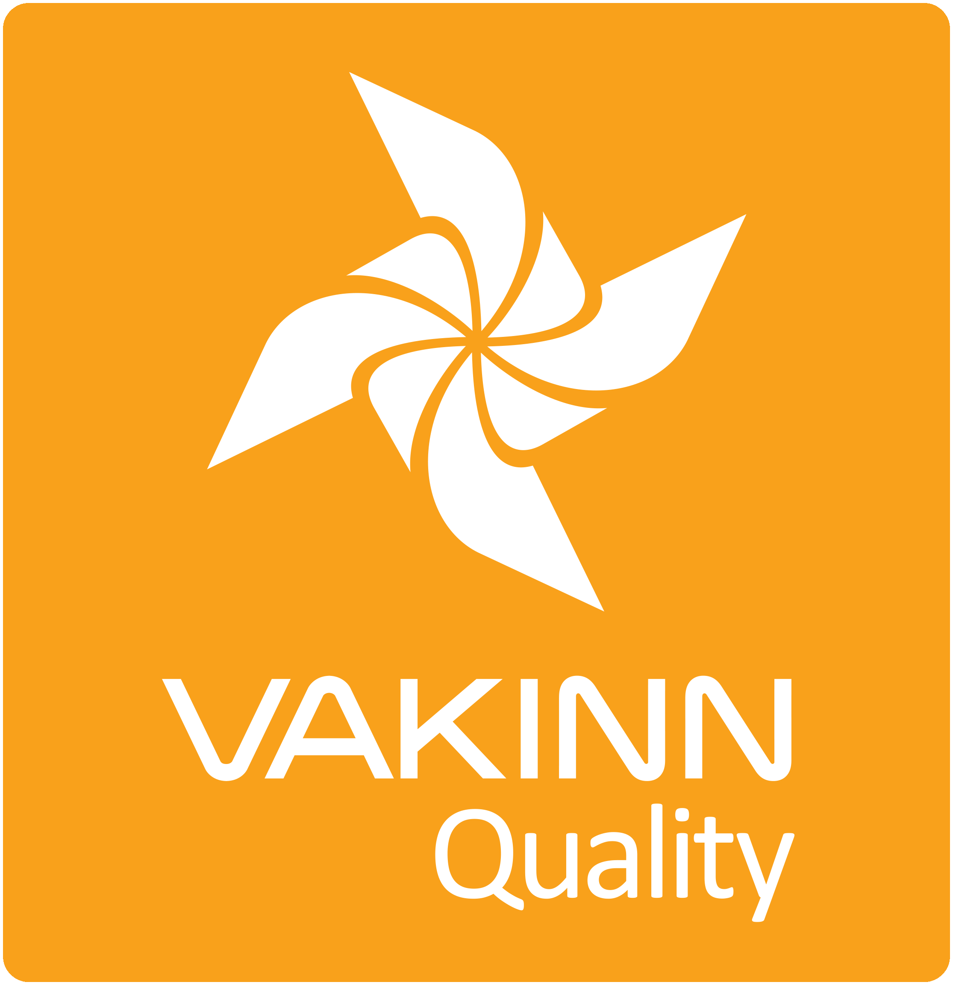

Vakinn Code of Ethics

All companies participating in Vakinn must confirm and abide by the Vakinn Code of Ethics:

- The Company provides its customers with courteous and reliable service.
- The company maintains and respects confidentiality and discretion in all customer relations.
- The company is guided by professionalism, honesty and fairness in all communications and business
transactions.
- The company treats all its customers with equal respect and consideration regardless of e. g. gender,
origin, culture, sexual orientation, religious preferences, age, social standing and physical aptitude.
- The company ensures that all information provided to its customers is correct and that its
advertising provides a truthful and reliable impression of its services and facilities.
- The company prices goods and services unambiguously and in compliance with current legislation.
- The company makes an effort to answer all enquiries and requests professionally and efficiently.
- The company guarantees a fair and prompt handling of complaints.
- The company upholds and observes all laws and regulations pertaining to its operation.
- The company ensures that its bookkeeping and accounting is conducted in a professional manner.
- The company meets all its responsibilities towards employees by observing current laws and
collective labour agreements.
- The company ensures that all its employees receive proper training and that working conditions are
appropriate.
- The company ensures the safety of its employees and customers by means of professional work
practices and by maintaining high standards of facilities and equipment.
- The company demonstrates responsibility towards Iceland’s nature, environment and society.
- The company upholds the interests and reputation of Iceland as a high quality.

See specific quality criteria on vakinn.is.
One example of each is sufficient along with a confirmation that contracts are in place for all members of the staff and contractors. Personally identifiable information should be avoided
Available in Icelandic
One example is sufficient along with a confirmation that such documents exist for all employees.
Available in Icelandic
Photo/s required.
This does not refer to employees working in the office.
Available in Icelandic
The criteria in chapter four apply to the bronze label of the environmental certification. If the company requests silver or gold certification, the applicable environmental criteria no. 300 must be fulfilled.
See checklist on vakinn.is
Available in Icelandic.
Photo / photos must be submitted along with written instructions.
Valid from 1.1.2024.

