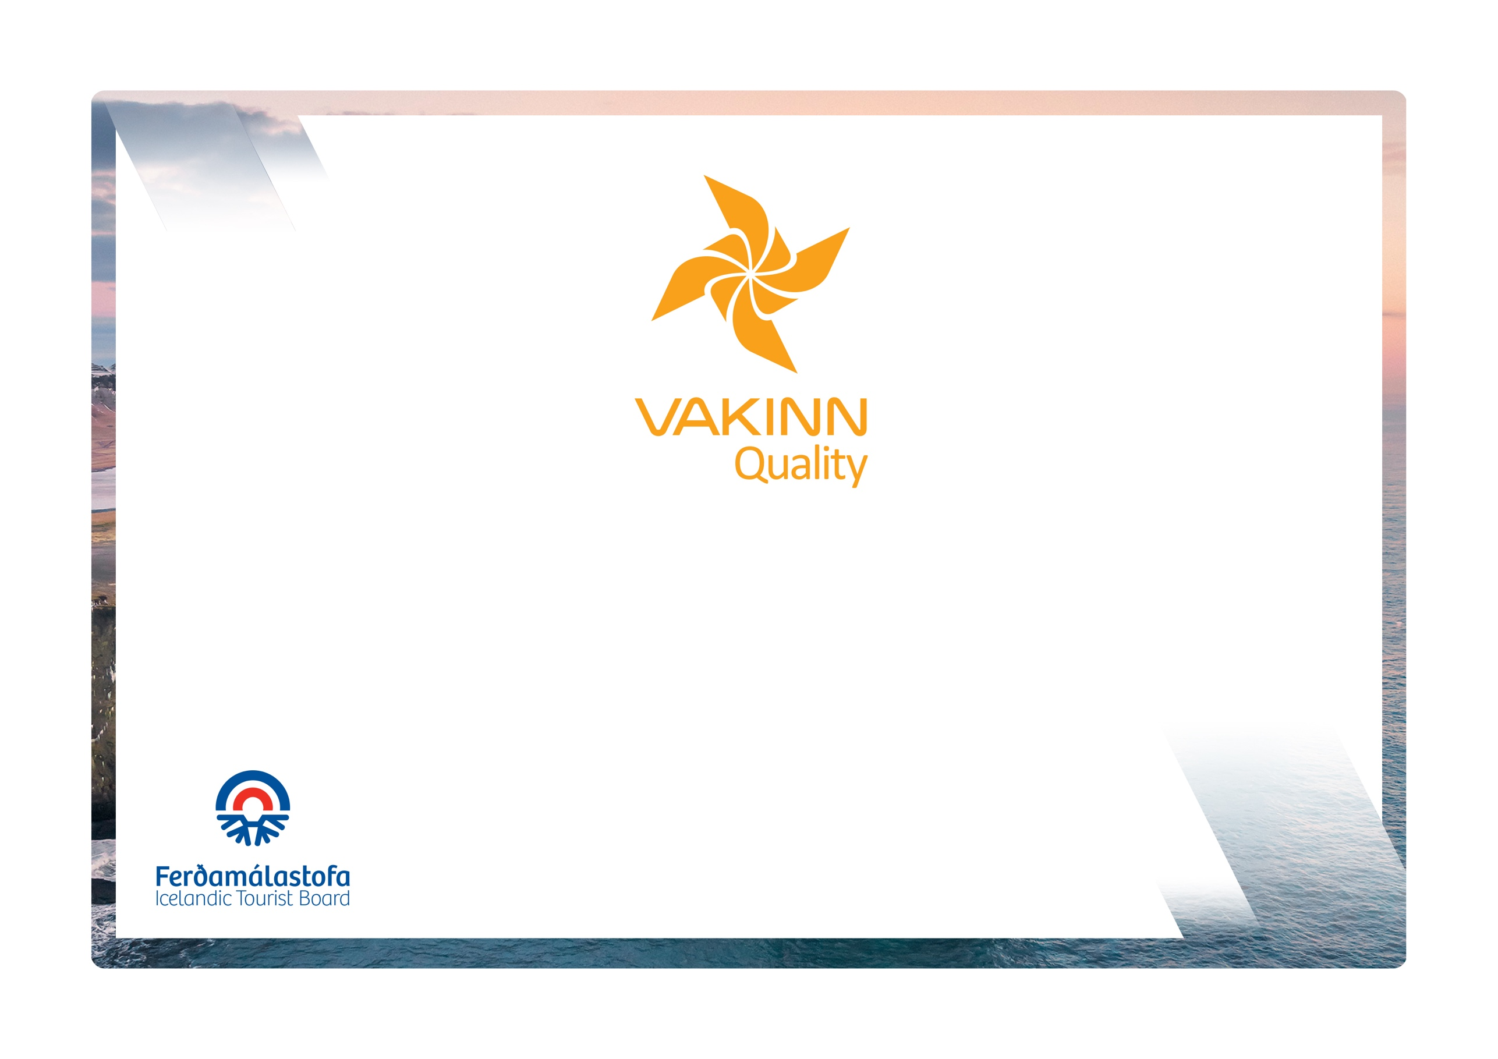

Kayaking

vakinn.is
Quality and Environmental Certification
On the Way to Sustainable Tourism

Specific Quality Criteria no. 218
5th edition 2022
The following quality criteria are filled out by a company representative. A clear explanation of how each applicable criterion is fulfilled must be given with reference to appropriate documentation, e. g. employee handbook/quality manual, safety plans, photos etc. Random and/or selected criteria will be verified by the auditor.
218-1 | Safety | Yes | N/A | How fulfilled/explanation
218-1.1 | For each type of tours there is an itinerary (written description) including a description of routes, schedule and other trip arrangements.
218-1.2 | The itinerary shall include e.g.:  - Route map.  - Description of weather conditions, tides and currents in the area and their effects.  - Information on facilities in the area, e. g. camping and caravan/camper sites, huts, road-ends, safe landing places and access to water supplies.  - Information on the risks found in the area, e. g. reefs, shallows and shipping routes.
218-1.3 | The company keeps a record of customers, guides and other employees on each trip. Details of each kayak and equipment are recorded.
218-1.4 | A checklist has been compiled for safety equipment on tours and excursions, including f.ex.:  - First aid kit/equipment.  - Communication devices.  - Tracking devices.  - Extra clothing.  - Other equipment according to conditions on each tour.
218-1.5 | It is clear who carries safety equipment with them and under what conditions it should be used.
218-1.6 | The minimum age for participation in kayaking is specified in the company’s safety plan. A parent/guardian must confirm permission for the participation of minors.
218-1.7 | Written criteria apply to the passenger/guide ratio according to conditions on each tour e.g.:  - 6:1 open fjords/bays and larger lakes.  - 8:1 lakes/lagoons and less dangerous areas.
218-1.8 | A written plan for renewal, cleaning and maintenance of safety  equipment is in place including procedures about i.a.:  - Inspection and testing of equipment.  - Disinfection and cleaning of equipment.  - Lifespan of equipment (see manufacturer's accepted standards).
218-1.9 | All equipment is well and neatly stored after usage. The storage is appropriate and does not reduce the safety and usability of the equipment.
218-1.10 | To prepare guides for the tours/activities of each day they go through a checklist including the following items, among others:  - Details of the itinerary and routes to be travelled.  - Weather forecast.  - Tide tables.  - Equipment.  - Information about customers  - That contingency plans are always included / accessible on tours.
218-1.11 | There is a checklist for guides on the safety matters that are covered with customers before and during the tour, e. g. regarding:  - Local conditions and weather.  - Schedule.  - Safety precautions in situations where special care must be exercised, i.a. where there is strong wind or waves.  - Instructions on the use, preparation and adjusting of kayaks and other equipment such as spray decks, rudder pedals and floating devices/life jackets.  - Directions on paddling and steering.  - Information on the use of emergency equipment e. g. cleaning pumps, bailing devices, torches/flares, spare paddles, repair kits.  - Instructions on how to react if a kayak capsizes including techniques to free oneself from the kayak  - Instructions on surf-landing and launching if appropriate  - Appropriate clothing and equipment.  - Food, drinks, and access to water during the tour.  - 112 emergency number in Iceland.
218-1.12 | The company informs employees and customers of the necessity of being in good physical condition and that the use of alcohol or drugs can make them unfit to take part in a tour.
218-1.13 | The guide continually monitors weather and sea conditions as well as ability of participant. In the case of multi-day tours, guides have access to weather forecasts during the entire trip.
218-1.14 | For all tours, whether with or without a guide, customers receive the following:  - A well-maintained kayak and equipment properly adjusted for the intended use  - One paddle per person.  - A spray deck of the correct size for each client (except for „sit on top“ kayaks).  - A properly fitting lifejacket/life vest, with whistle, for each client.  - A bailing device for each kayak. Also at least one bilge pump per group, which can be used without removing the spray deck, unless the cockpit is self-draining.  - A minimum of two appropriate waterproof distress flares per group.  - A minimum of two waterproof maps.
218-1.15 | The company has written guidelines on when to cancel tours due to weather. It is clearly stated who decides on the cancellation of tours.
218-2 | Environment | Yes | N/A | How fulfilled/explanation
218-2.1 | Marked roads or recognised vehicle tracks are always used. Off-road driving in winter and on glaciers shall be in accordance with Article 4. of Regulation no. 528/2005 regarding restrictions on traffic in Iceland's nature.
218-2.2 | Customers are informed about toilet arrangements where conventional facilities are not available.
218-2.3 | All equipment and waste are removed. The company ensures that no permanent traces/damages are seen in the nature in connection with the company’s tours or activities.
218-2.4 | At the beginning of the tour, the guide reminds the customer of responsible travel behaviour.
218-3 | Education and Training | Yes | N/A | How fulfilled/explanation
218-3.1 | Guides receive training in the use of equipment f. ex. to be able to provide a correct location and information on accessibility to areas visited if assistance is required. In the training the following shall be covered:  - Use of compass and map.  - Use of GPS positioning device.  - Use of appropriate means of communication for different areas, e. g. mobile phone, radio and Tetra.
218-3.2 | Guides have received appropriate training in handling boats and equipment.
218-3.3 | Guides have extensive knowledge and experience of kayaking in the area being travelled.
218-3.4 | Guides have completed the course Wilderness First Aid (Fyrsta hjálp 1, 20 hours) from ICE-SAR or a comparable First Aid course from another organization and attend a refresher course (4 hours) every two years.
218-3.5 | At least one guide on tours through the wilderness* has completed the course Wilderness First Responder (WFR) from ICE-SAR or a comparable course from another organization and attends a refresher course every three years.
218-3.6 | At least one employee on each tour, e.g. guide, has completed the course Swiftwater Rescue Technician 2 (Holds a valid licence as a Swiftwater Rescue Technician from a certified agency i.e. ICE-SAR or Rescue 3 International).
218-3.7 | The head guide in sea-kayaking tours has completed ISKGA Costal Guide or BCU 4 Star Leader.
218-3.8 | Guides in Sit on Top (SOT) kayaking tours has completed SOT safety course according to ISKGA.

* Wilderness is a place or area where it takes at least two hours to get assistance/rescue from first responders by land.

