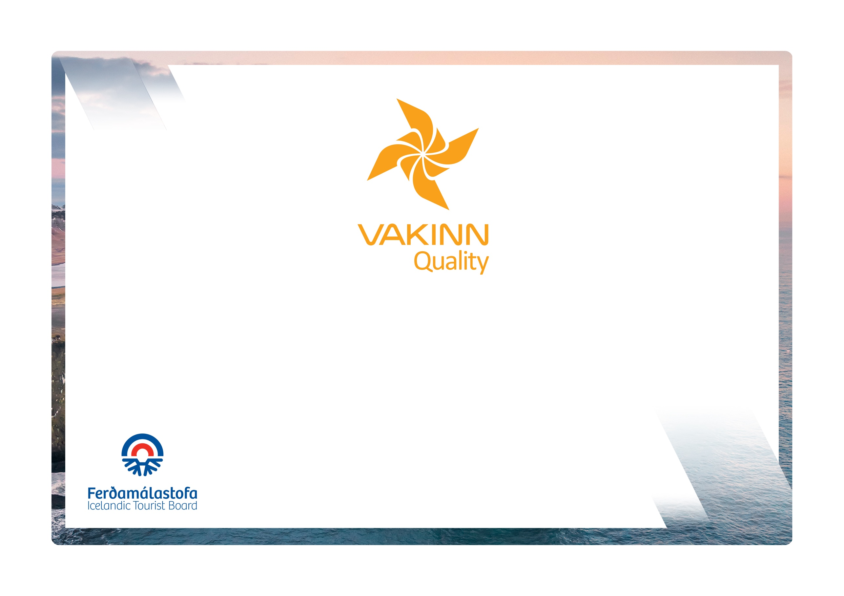
vakinn.is

Sea Angling

The following quality criteria are filled out by a company representative. A clear explanation of how each applicable criterion is fulfilled must be given with reference to appropriate documentation, e. g. employee handbook/quality manual, safety plans, photos etc. Random and/or selected criteria will be verified by the auditor.
Quality and Environmental Certification
On the Way to Sustainable Tourism

Specific Quality Criteria no. 215
5th edition 2022
215-1 | Safety | Yes | N/A | How fulfilled/explanation
215-1.1 | For each type of tours there is an itinerary (written description) including a description of routes, schedule and other trip arrangements.
215-1.2 | A checklist has been compiled for safety equipment on tours and excursions, including f.ex.:  - First aid kit/equipment.  - Communication devices.  - Tracking devices.  - Extra clothing.  - Other equipment according to conditions on each tour.
215-1.3 | A written plan for renewal, cleaning and maintenance of safety equipment is in place including procedures about i.a.:  - Inspection and testing of equipment.  - Disinfection and cleaning of equipment.  - Lifespan of equipment (see manufacturer's accepted standards).  - Maintenance and cleaning of fishing equipment.
215-1.4 | Equipment that has been used abroad is disinfected according to current applicable regulations.
215-1.5 | Knives and other utensils that may pose a danger are stored in a safe place where there is no danger to passengers or crew members.
215-1.6 | All equipment is well and neatly stored after usage. The storage is appropriate and does not reduce the safety and usability of the equipment.
215-1.7 | To prepare guides/captains for the tours/activities of each day they go through a checklist including the following items, among others:  - Details of the itinerary and routes to be travelled.  - Weather forecast.  - Equipment.  - Information about customers.  - That contingency plans are always included / accessible on tours.
215-1.8 | There is a checklist for guides/captains on the safety matters that are covered with customers before and during the tour, e. g. regarding:  - Local conditions and weather.  - Schedule.  - Safety precautions.  - Appropriate clothing and equipment.  - Food, drinks, and access to water during the tour.  - 112 emergency number in Iceland.
215-1.9 | The company has written guidelines on when to cancel tours due to weather. It is clearly stated who decides on the cancellation of tours.
215-1.10 | Customers are reminded of responsible travel behaviour.
215-2 | Education and Training | Yes | N/A | How fulfilled/explanation
215-2.1 | Emergency response is trained every year. Training is based on the type of trip. Written description of how this is done is in place.
215-2.2 | Guides and captains have specialized training and experience appropriate for the tour in question.
215-2.3 | At least one crew member has completed the course Wilderness First Aid (Fyrsta hjálp 1, 20 hours) from ICE-SAR or a comparable course from another organisation and attend a refresher course (4 hours) every two years.

